Code :-<https://github.com/AmazonCodeBase/AmazonS3WithJava>

<https://www.youtube.com/watch?v=Cnf0wXowWDM&t=24s>

=================================================================

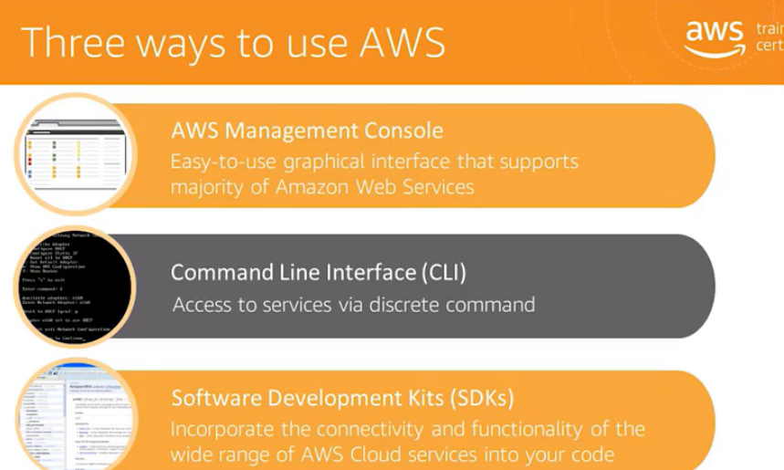

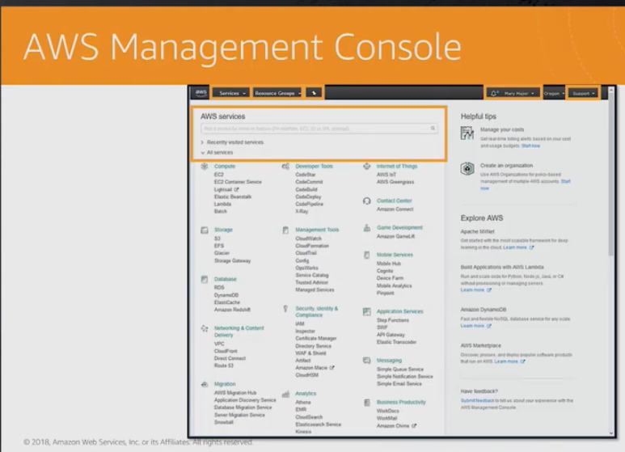

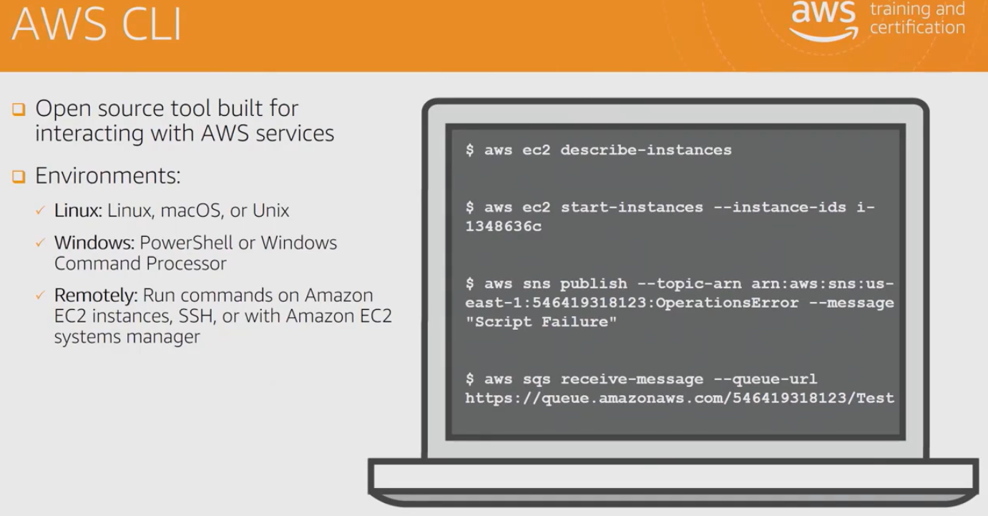

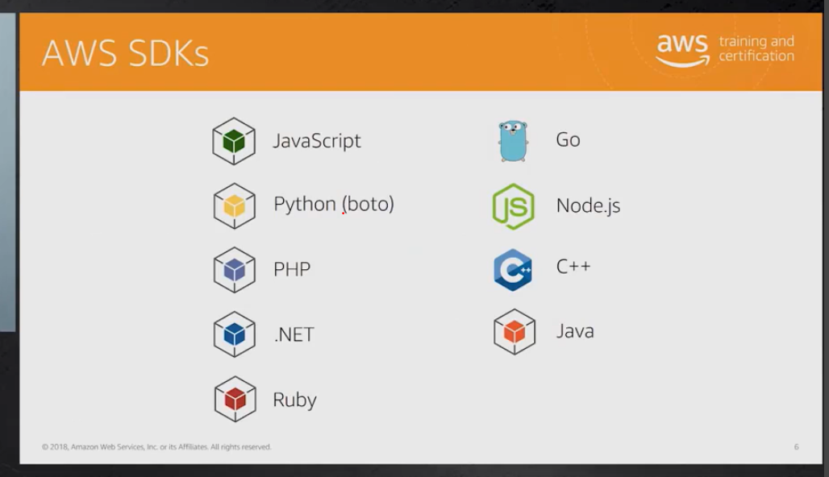

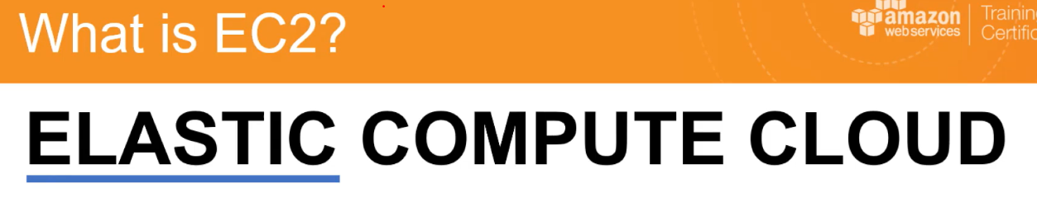

Amazon elastic cloud compute: we configure sw/hw/private key value pair to access from putty

Save it as ppk file from puttygen

**What is EBS?**

Amazon Elastic Block Store is a cloud-based block storage system provided by Amazon Web Services (AWS) that is best used for storing persistent data. ... Amazon **EBS** enables you to keep data persistently on a file system, even after you shut down your EC2 instance.

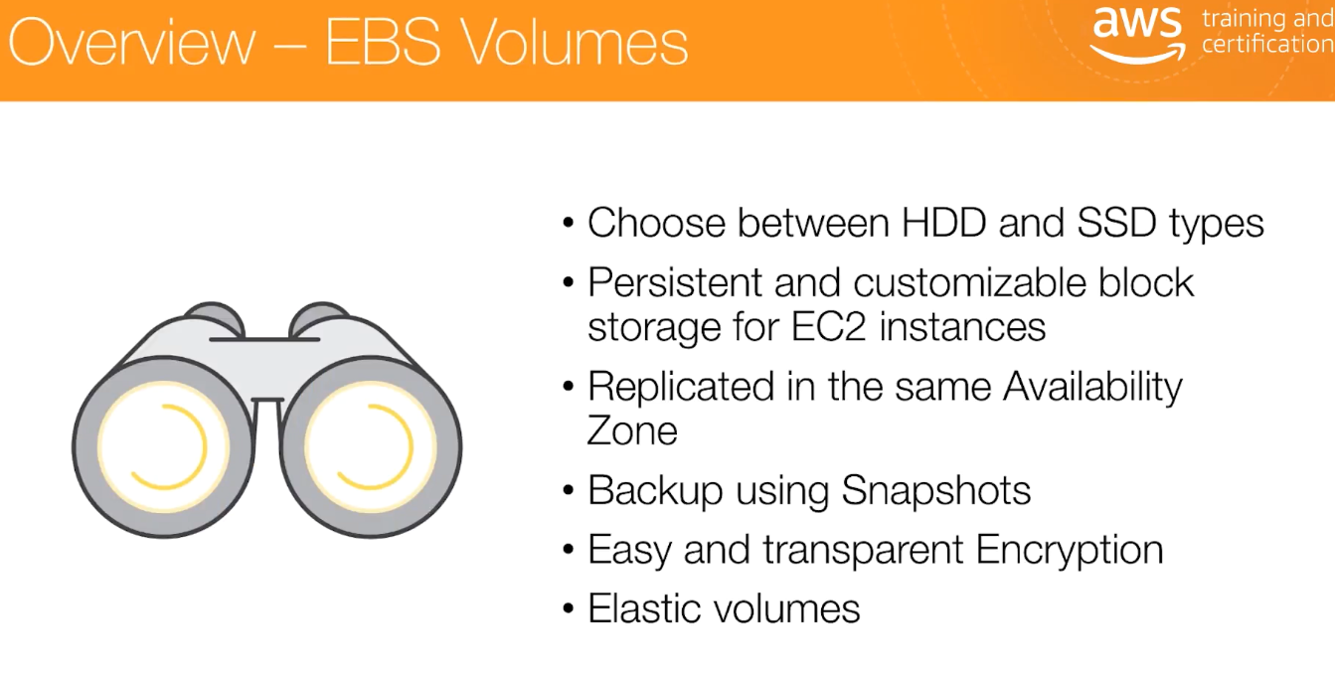

**What is a volume in AWS?**

An Amazon EBS **volume** is a durable, block-level storage device that you can attach to a single **EC2** instance. You can use EBS **volumes** as primary storage for data that requires frequent updates, such as the system drive for an instance or storage for a database application.

**Amazon EC2 (Elastic Compute Cloud)** is a virtual machine hosted in the cloud. When you want a computer, you can turn it on. When you no longer want it, you can turn it off. You only pay for it while you use it.

**Amazon EBS (Elastic Block Store)** is a virtual disk for your virtual machine, like your C: and D: drive. You can create any number of disks, each of any size.

**Amazon S3 (Simple Storage Service)** stores files, making them available on the Internet if you wish. Many popular services store their data in S3, such as Dropbox. You only pay for the data you store.

Attach volume to ec2 instance

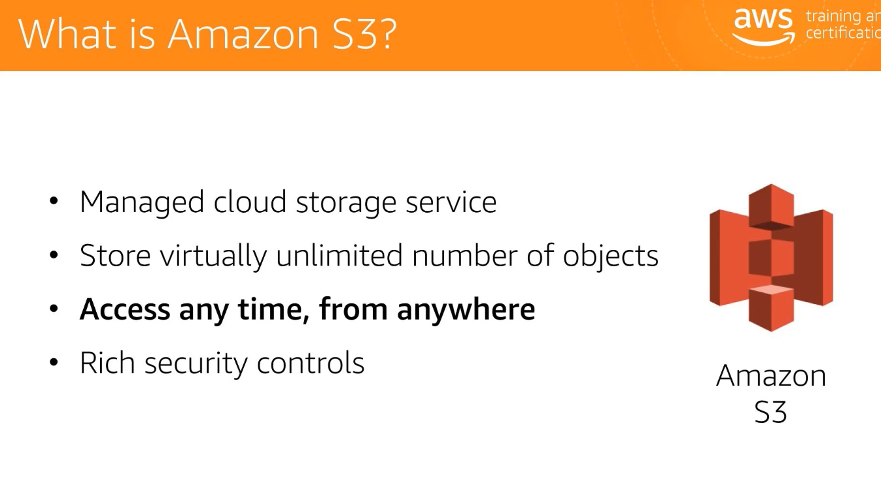

Put a video into s3

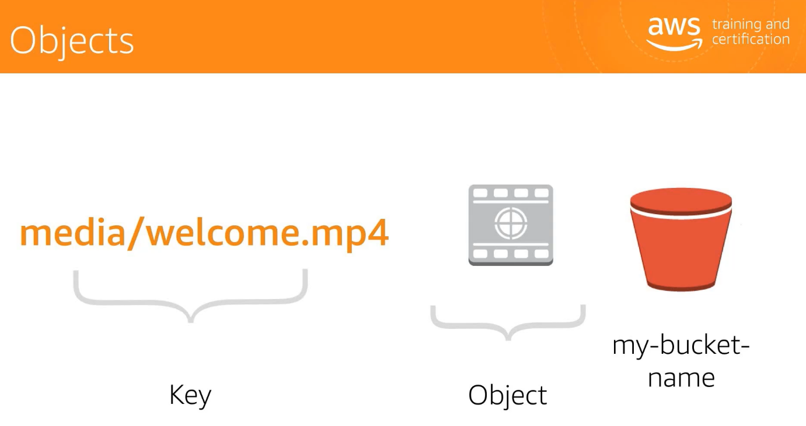

**Access the data from s3**

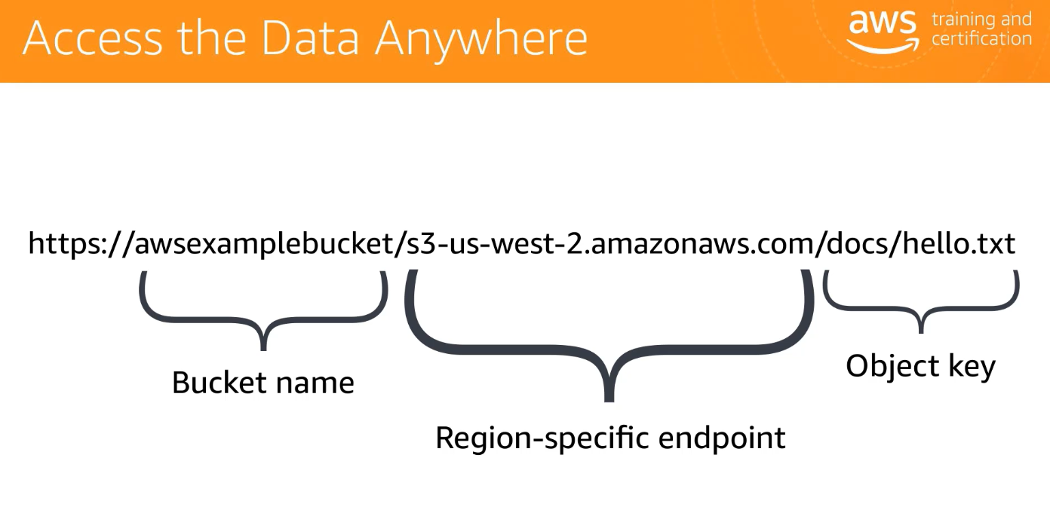

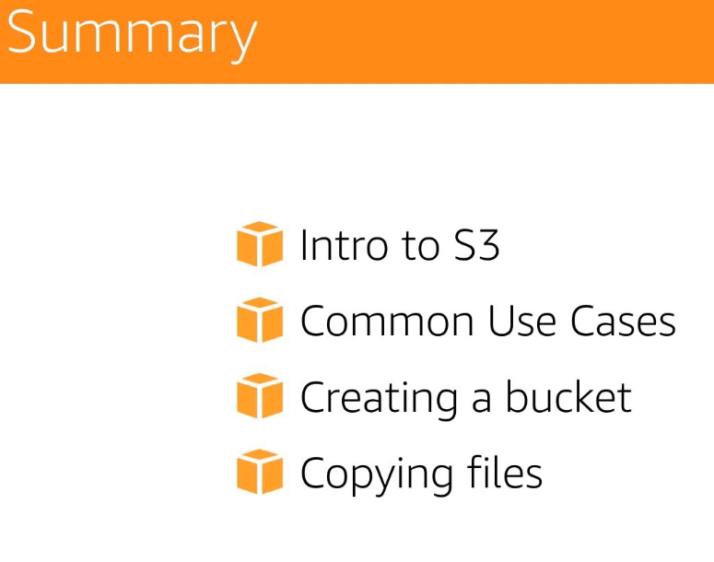

* + <http://www.differencebetween.net/technology/internet/difference-between-amazon-s3-and-amazon-ebs/>
  + EBS can only be used with EC2 instances while S3 can be used outside EC2
  + EBS appears as a mountable volume while the S3 requires software to read and write data
  + EBS can accommodate a smaller amount of data than S3
  + EBS can only be used by one EC2 instance at a time while S3 can be used by multiple instances
  + S3 typically experiences write delays while EBS does not

**Difference between region and availability zones :**

These locations are composed of **regions and Availability Zones**. Each **region** is a separate geographic area. Each **region** has multiple, isolated locations known as **Availability Zones**. **Amazon EC2** provides you the ability to place resources, such as instances, and data in multiple locations.

A **virtual private cloud** (VPC) is a **virtual** network dedicated to your **AWS** account. It is logically isolated from other **virtual** networks in the **AWS Cloud**. You can launch your **AWS** resources, such as Amazon **EC2** instances, into your VPC. ... A subnet is a range of IP addresses in your VPC.

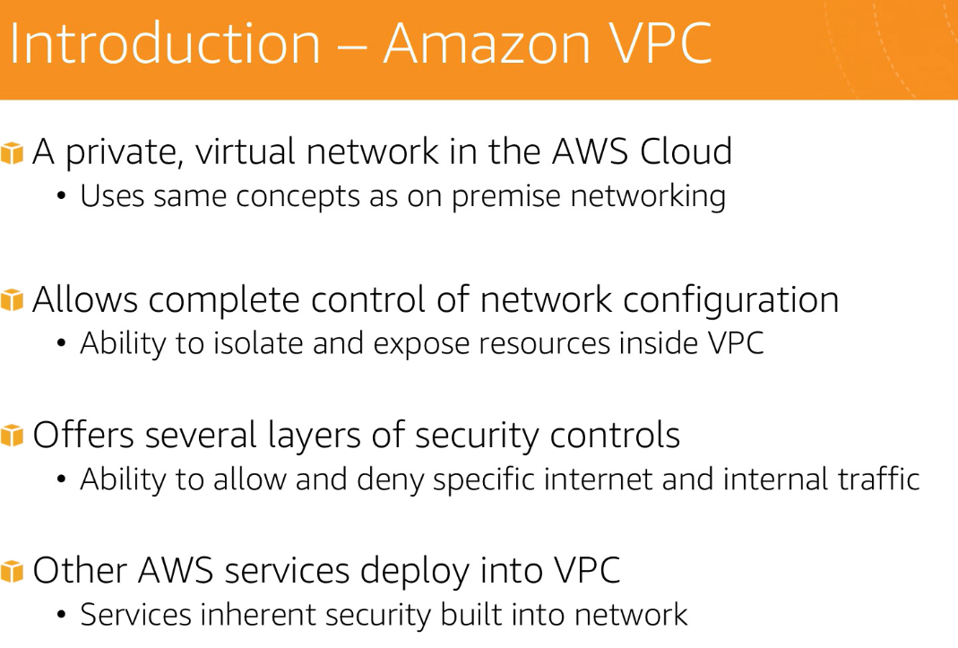

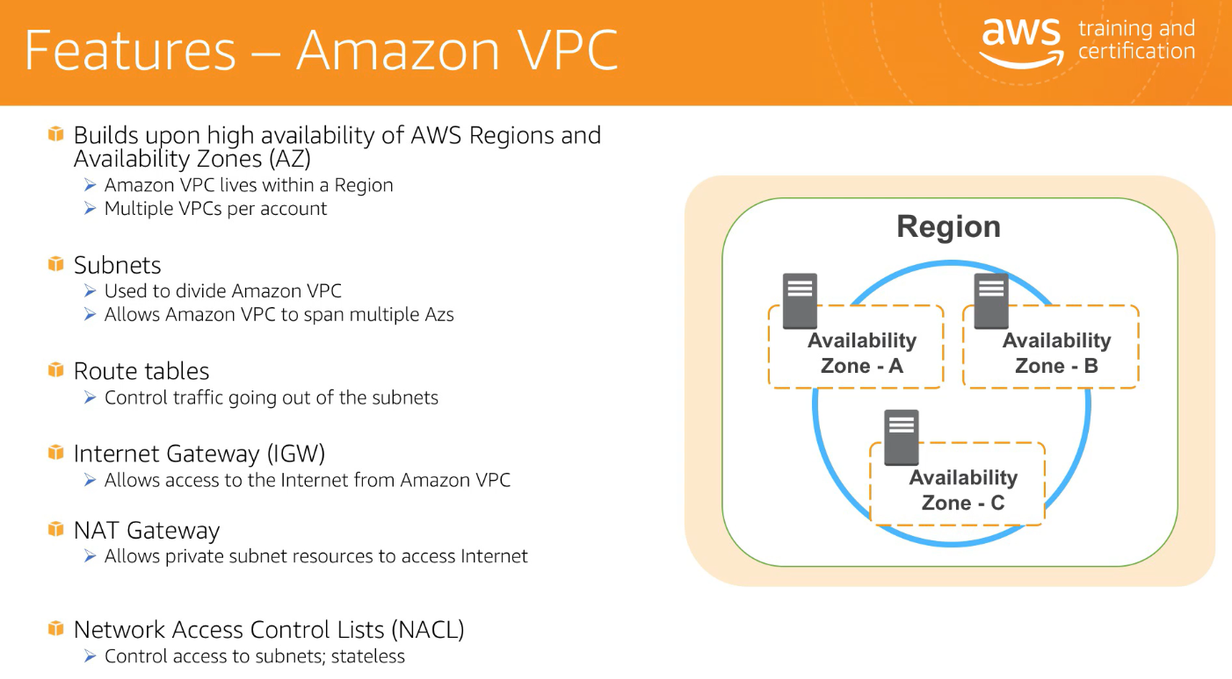

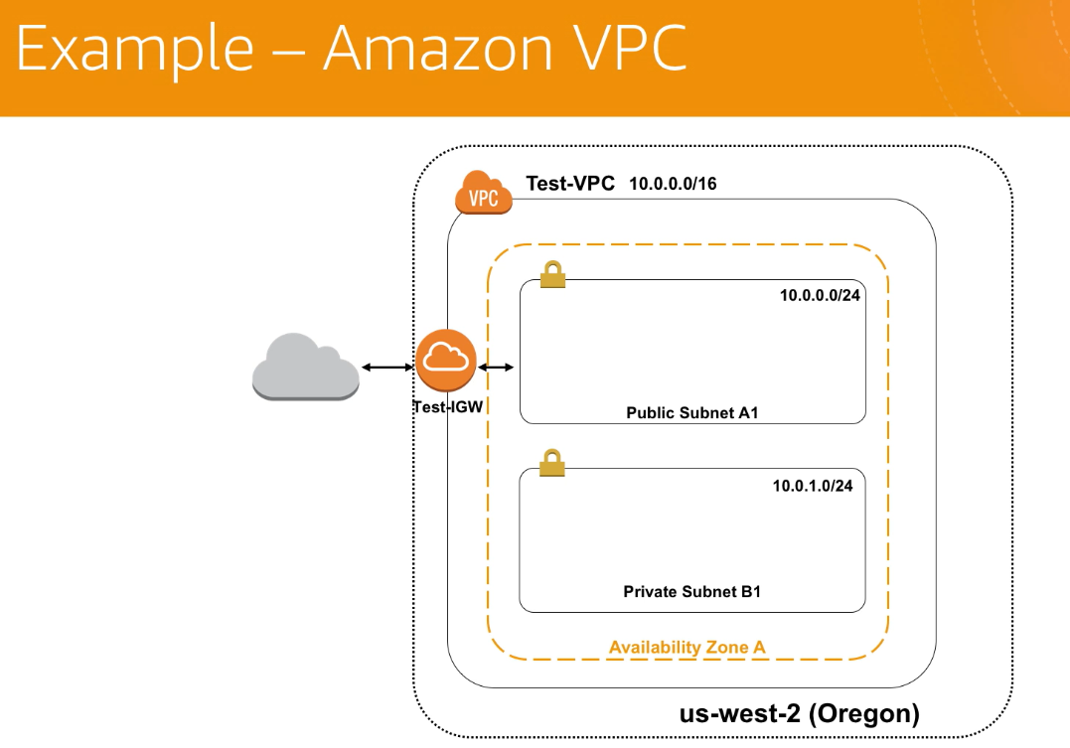

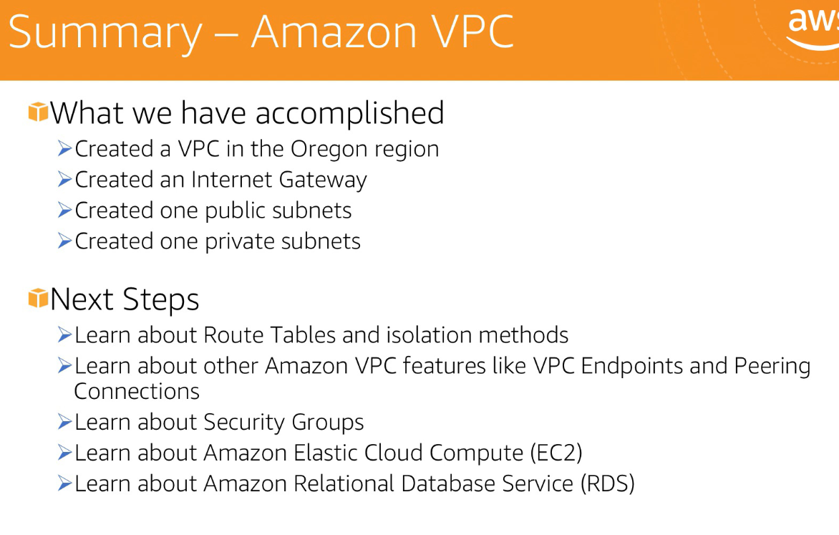

Note :allowing entire internet

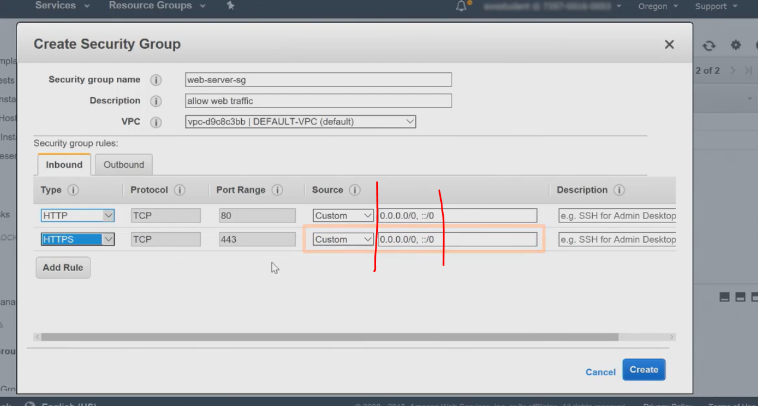

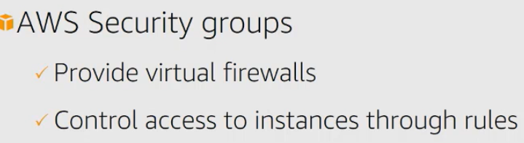

What is AWS application load balancer?

A **load balancer** serves as the single point of contact for clients. The **load balancer** distributes incoming **application** traffic across multiple targets, such as EC2 instances, in multiple Availability Zones. This increases the availability of your **application**. You add one or more listeners to your **load balance**

**Load Balancer Types**. Elastic **Load Balancing** supports the following **types of load balancers**: Application **Load Balancers**, Network **Load Balancers**, and Classic **Load Balancers**. Amazon ECS services can use either **type of load balancer**. Application **Load Balancers** are used to route HTTP/HTTPS (or Layer 7) traffic.

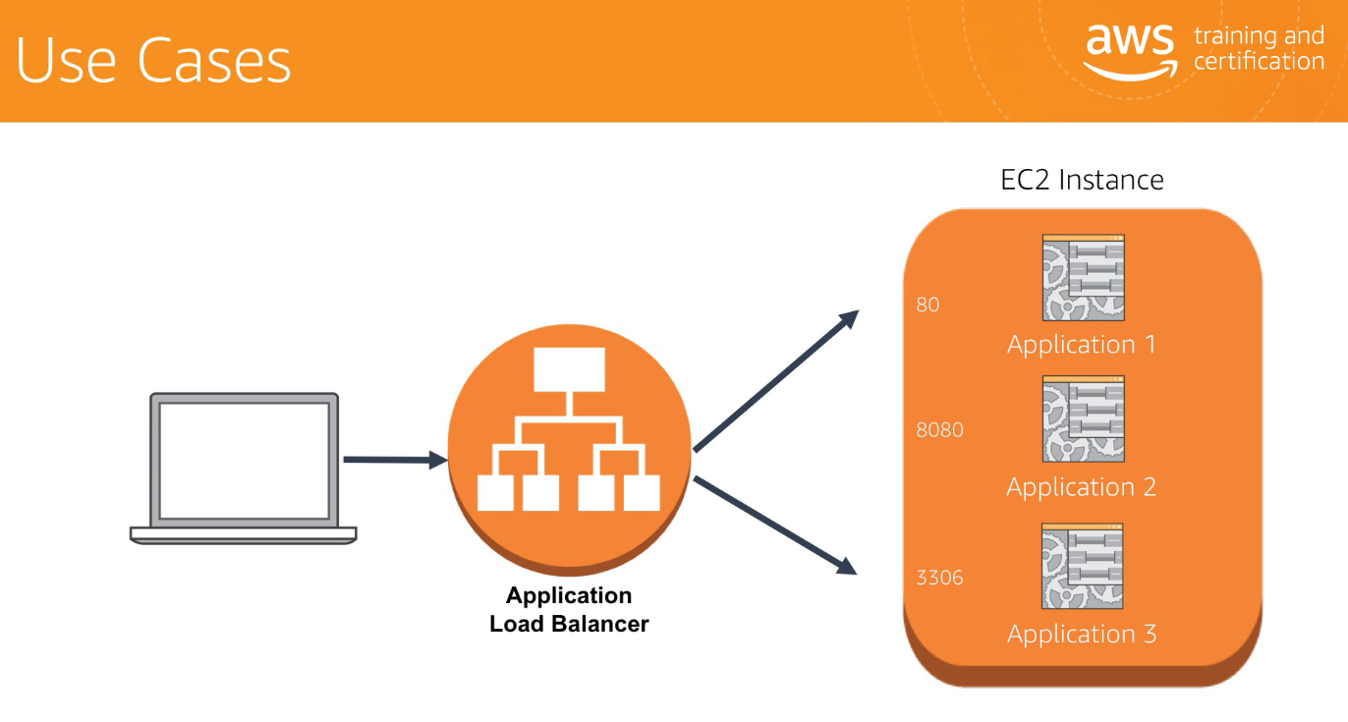

For multiple request it route to same instance running on different container through different port

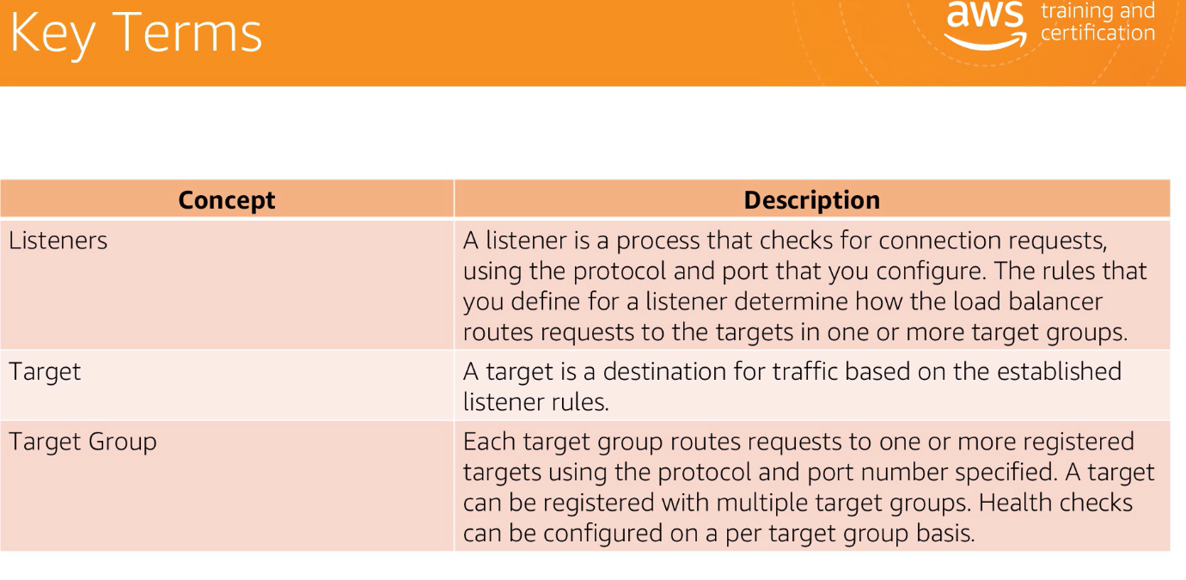

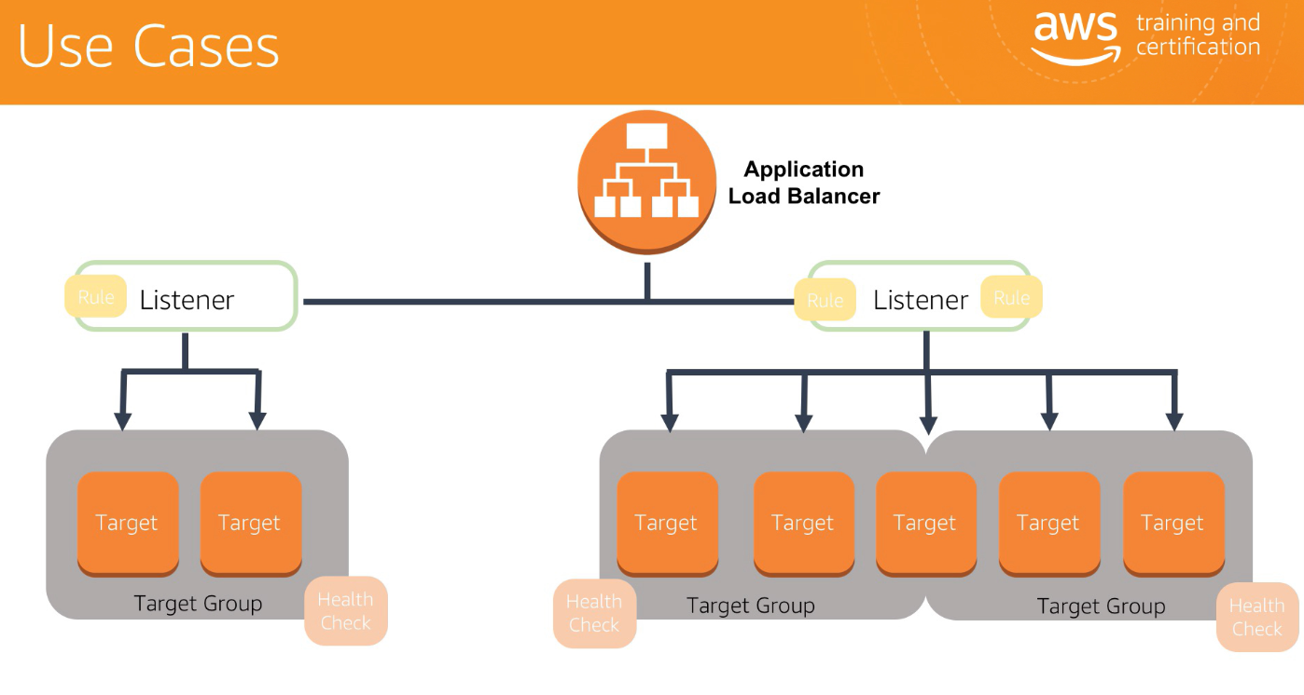

With **CloudWatch**, you can collect and access all your performance and operational data in form of logs and metrics from a single platform.

What is health check in load balancer?

Configure **Health Checks** for Your Classic **Load Balancer**. Your Classic **Load Balancer** periodically sends requests to its registered instances to **test** their status. These tests are called **health checks**.

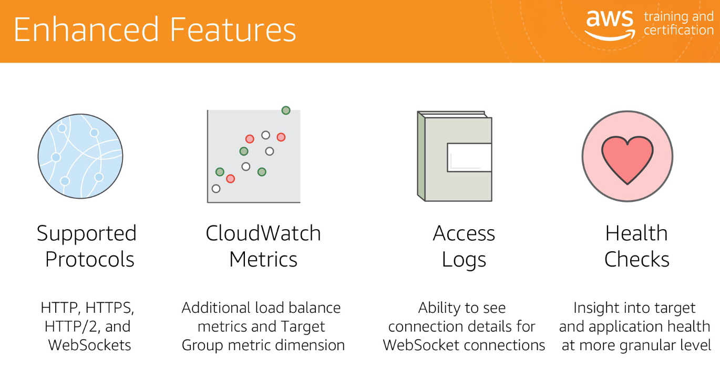

**Auto Scaling Group** is just a group of identical instances that AWS can scale up(add a new one) or down(remove) automatically based on some configurations you've specified. You use this to ensure at any point in time, there is the specific number of instances running your application, and when a threshold is reached(like CPU utilization), it scales up or down.

**Target Group** is a way of getting network traffic routed via specified protocols and ports to specified instances. It's basically load balancing on a port level. This is used mostly to allow accessing many applications running on different ports but the same instance.

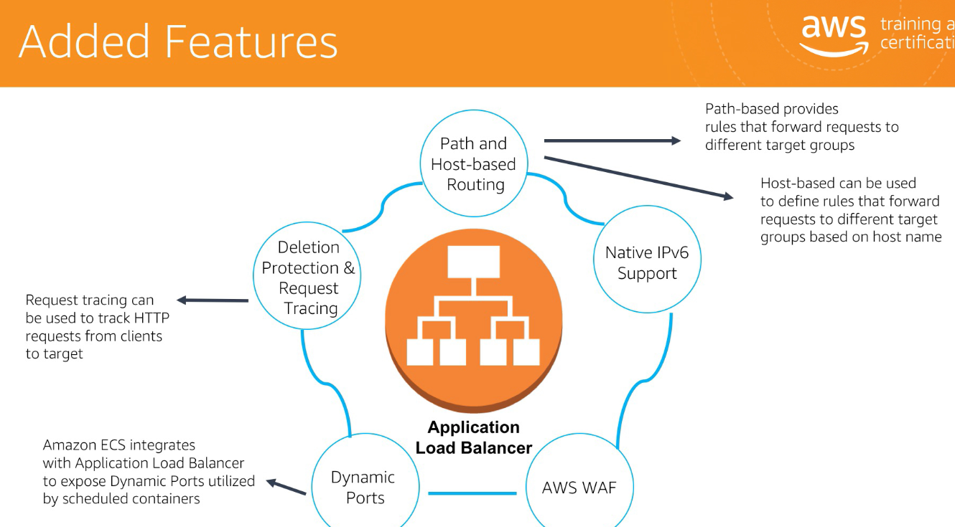

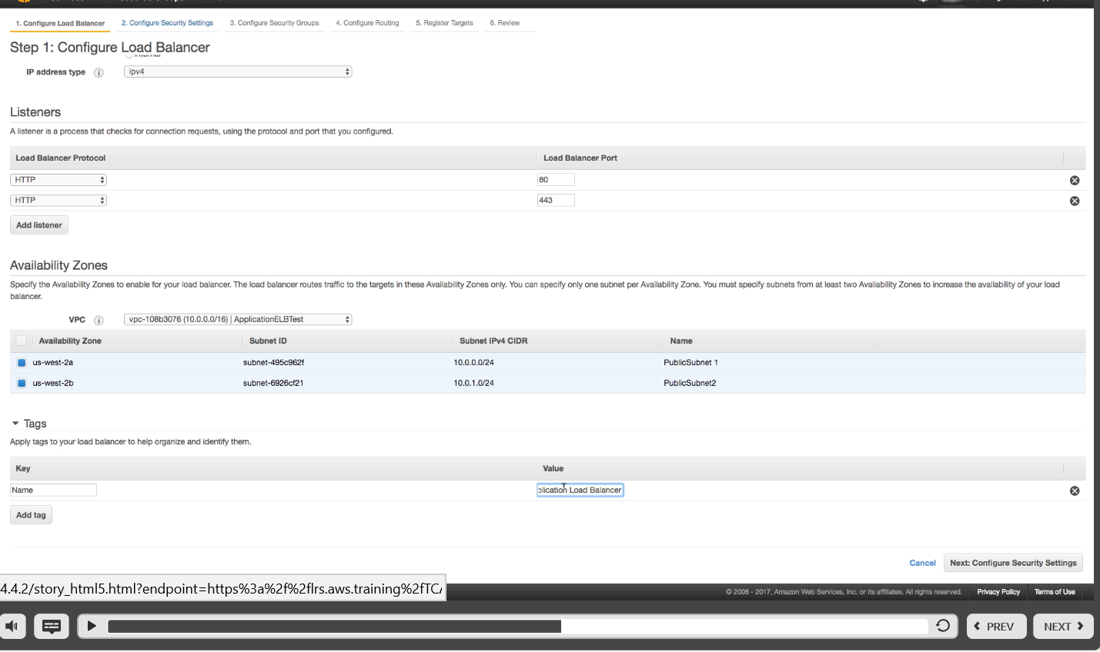

\

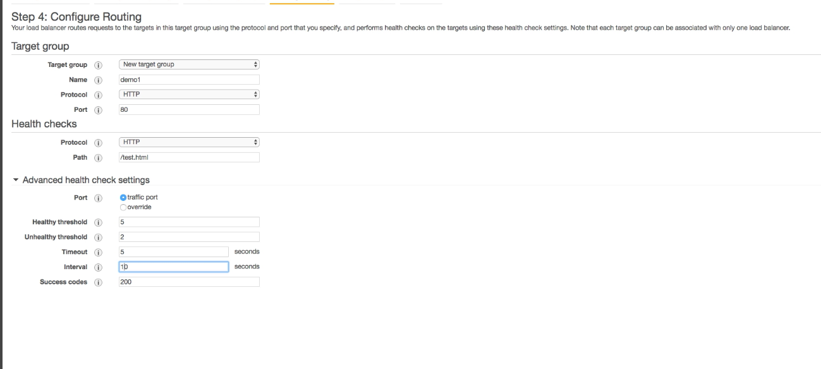

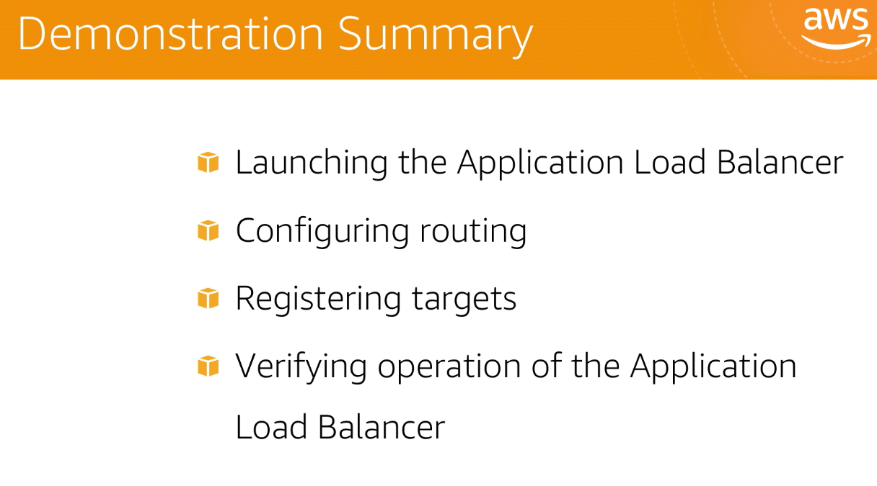

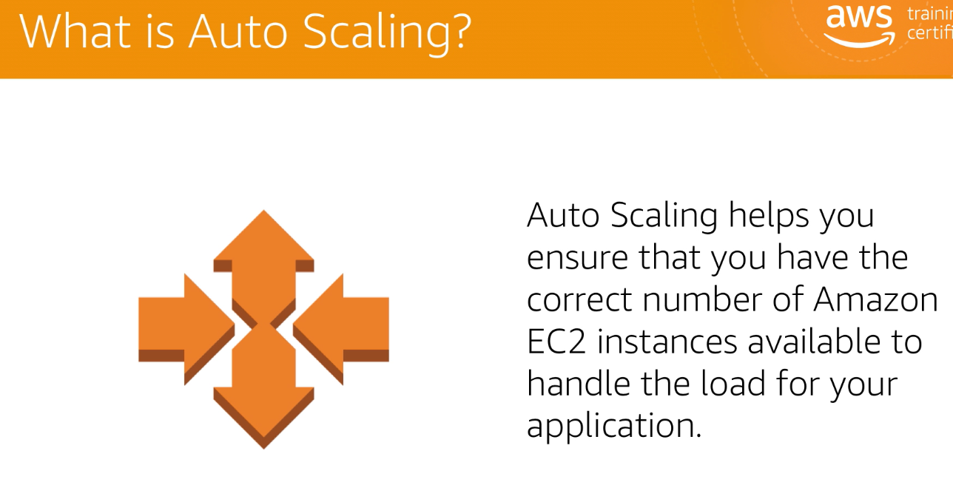

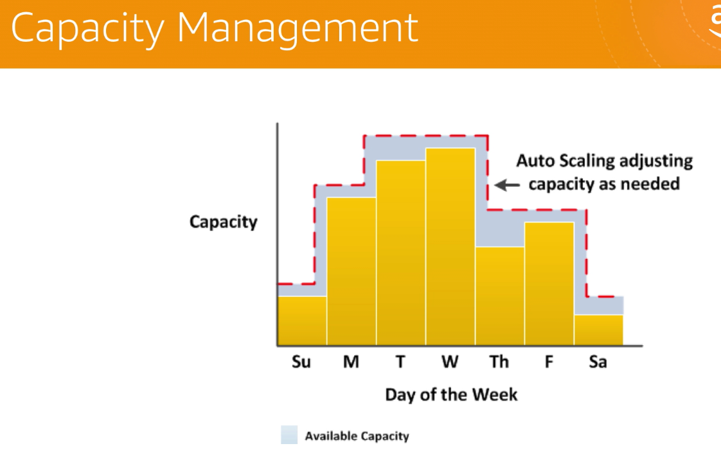

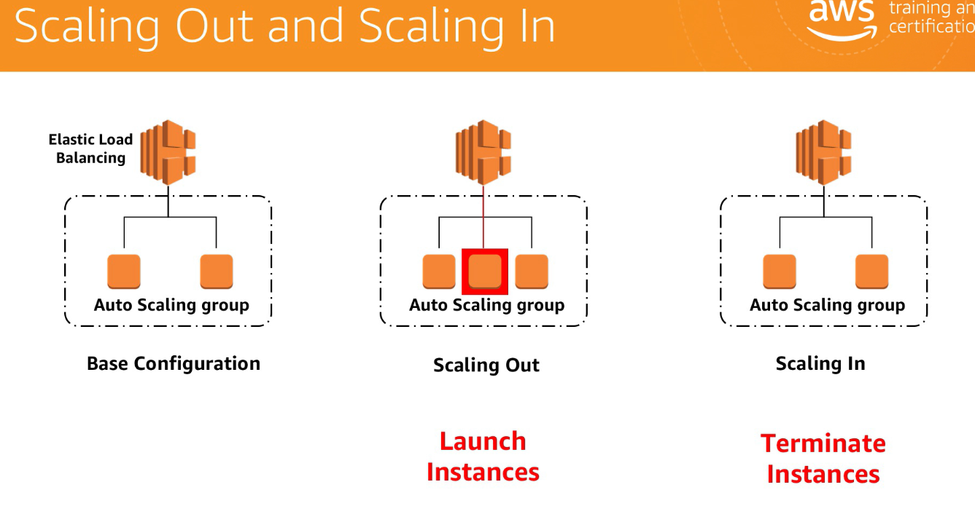

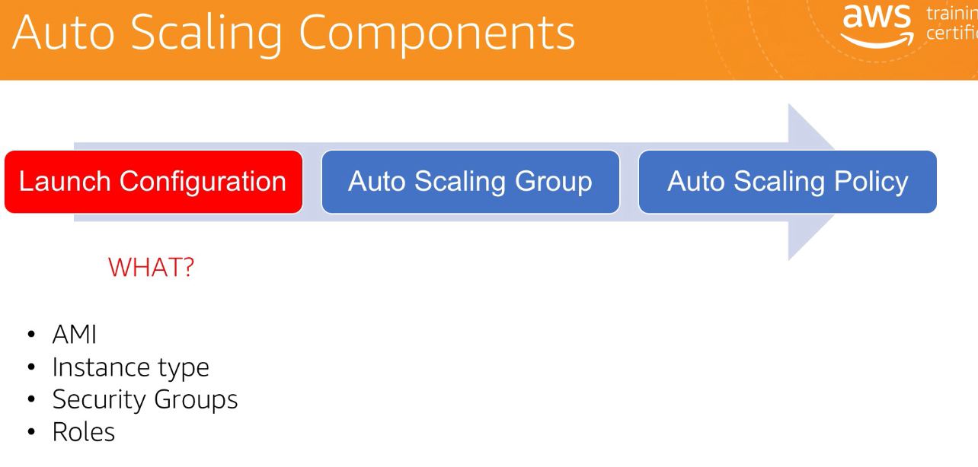

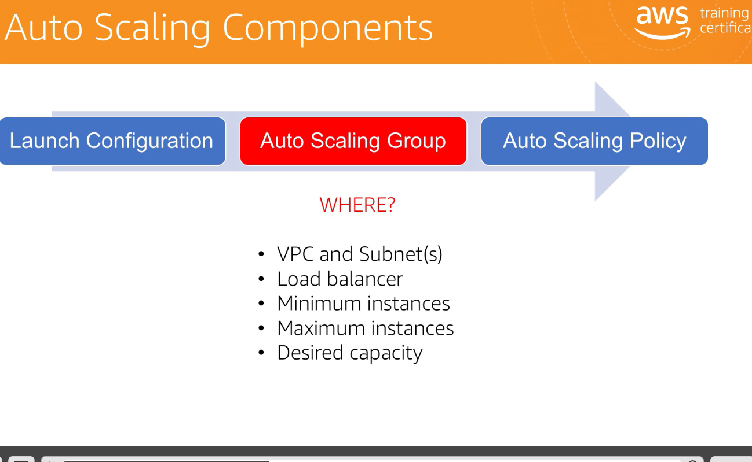

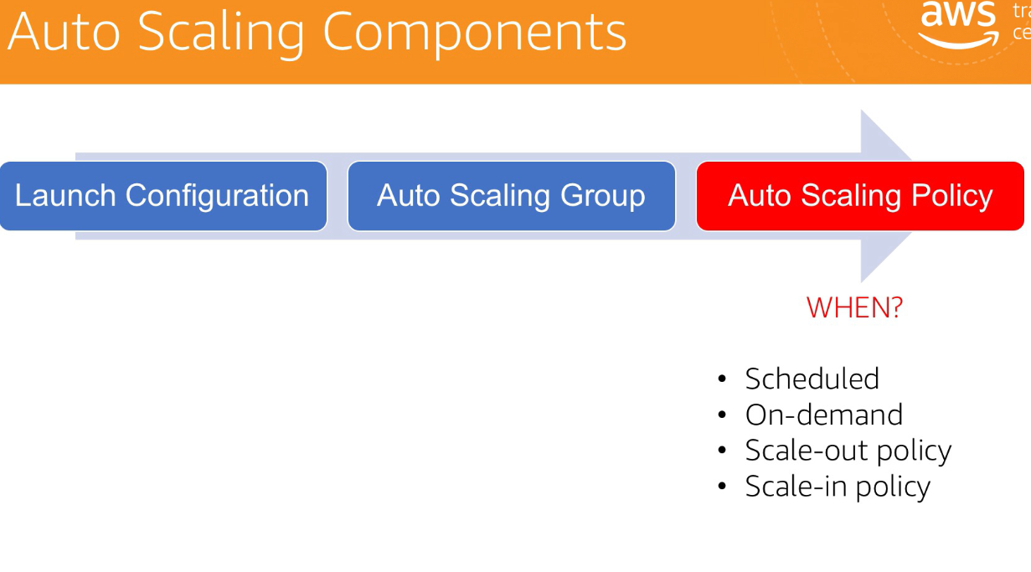

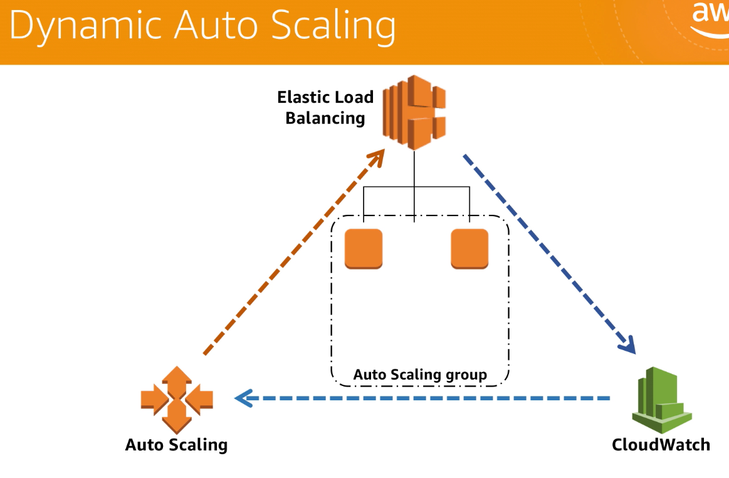

Autoscaling maintain workload dynamically

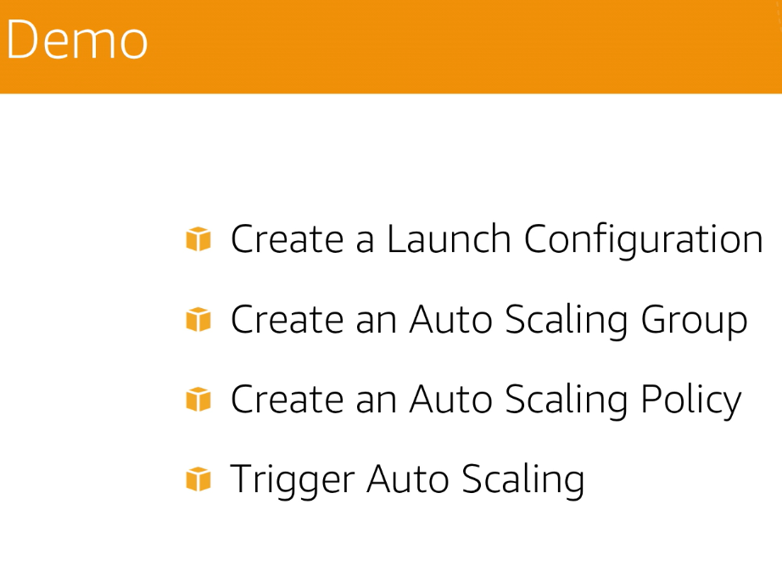

What does Amazon Route 53 do?

**Amazon Route 53** (**Route 53**) **is** a scalable and highly available Domain Name System (DNS) service. ... Customers are able to add, delete, and change any DNS records in their hosted zones. **Amazon** also offers domain registration services to **AWS** customers through **Route 53**.

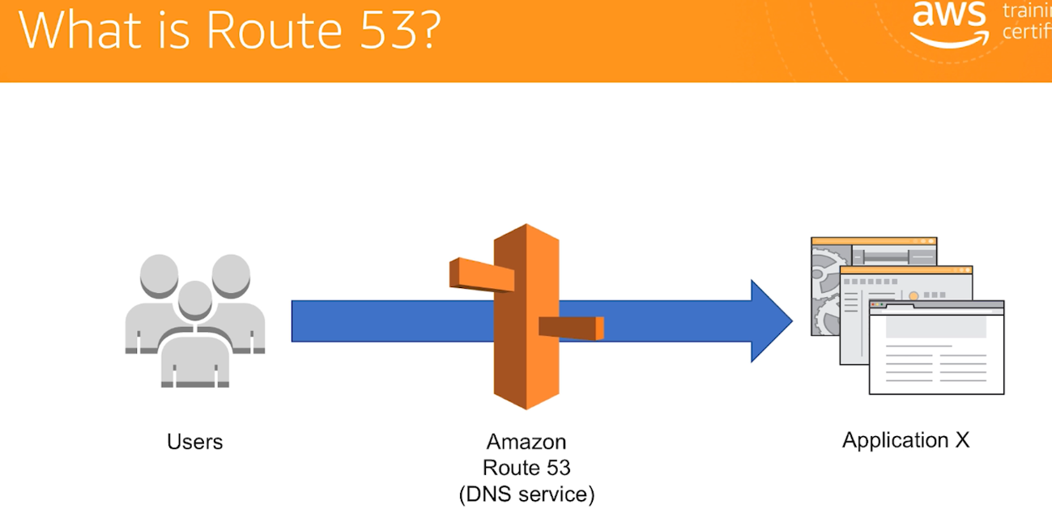

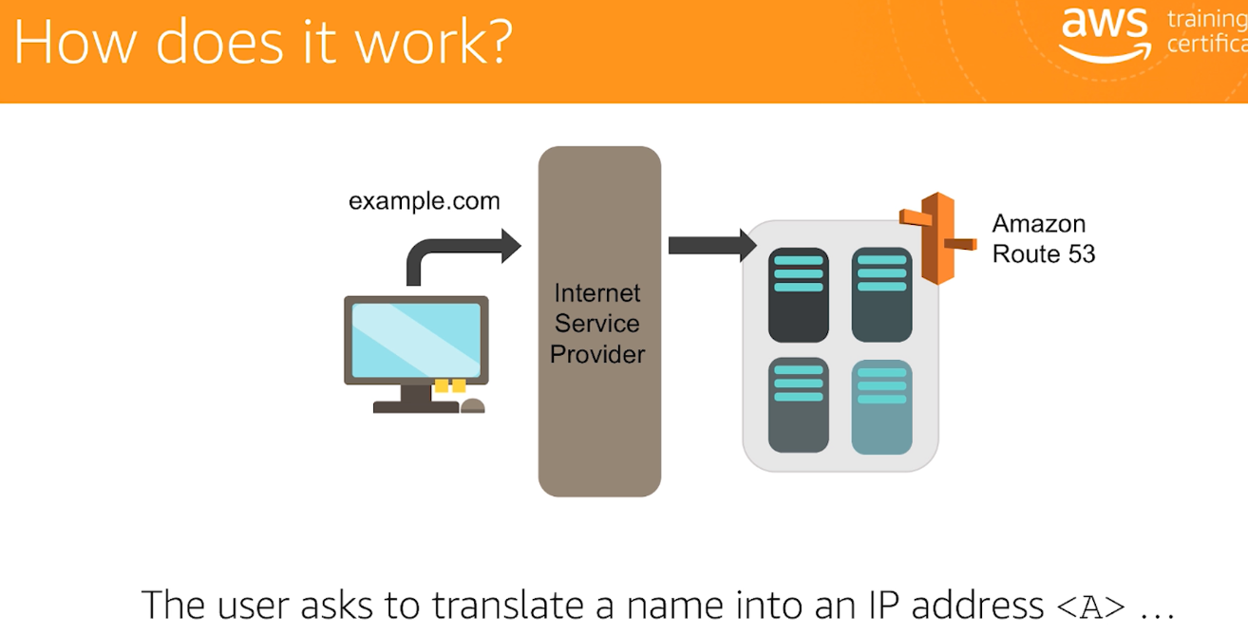

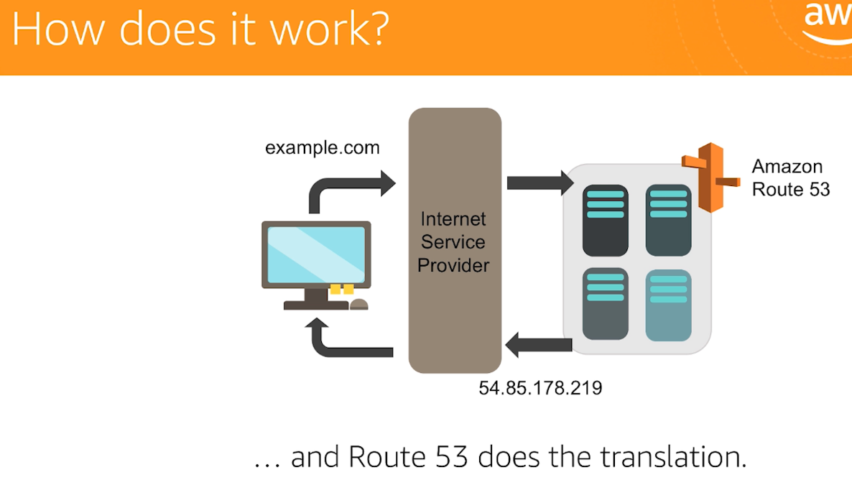

Route 53 support:

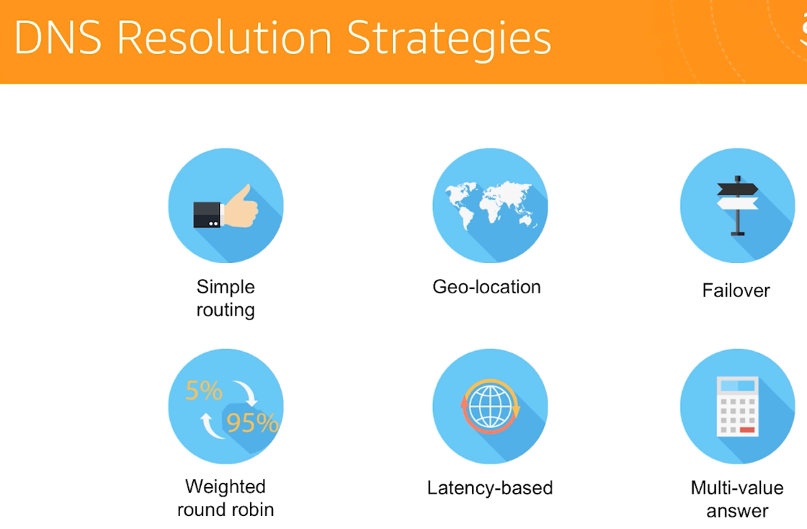

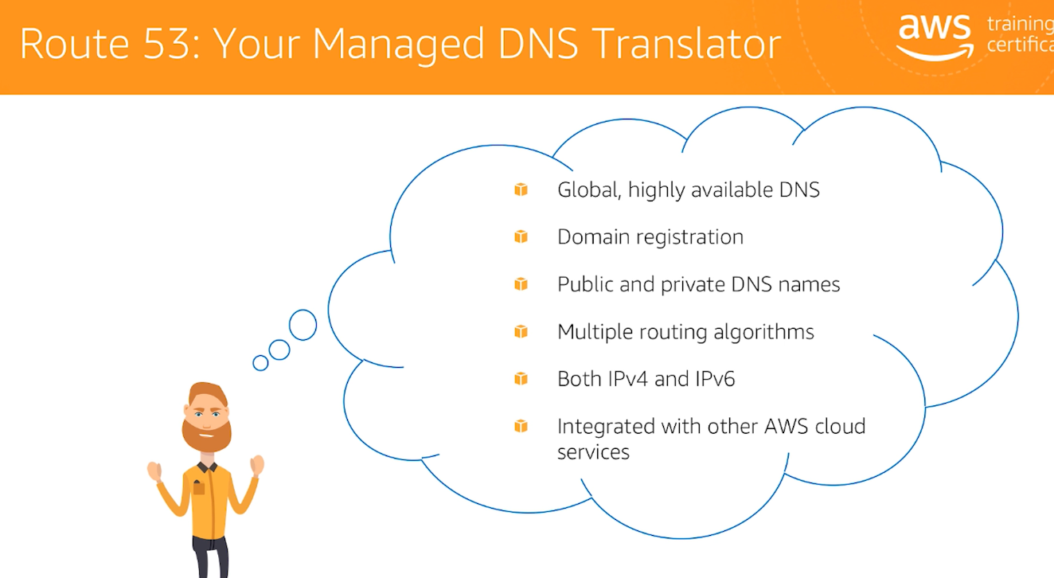

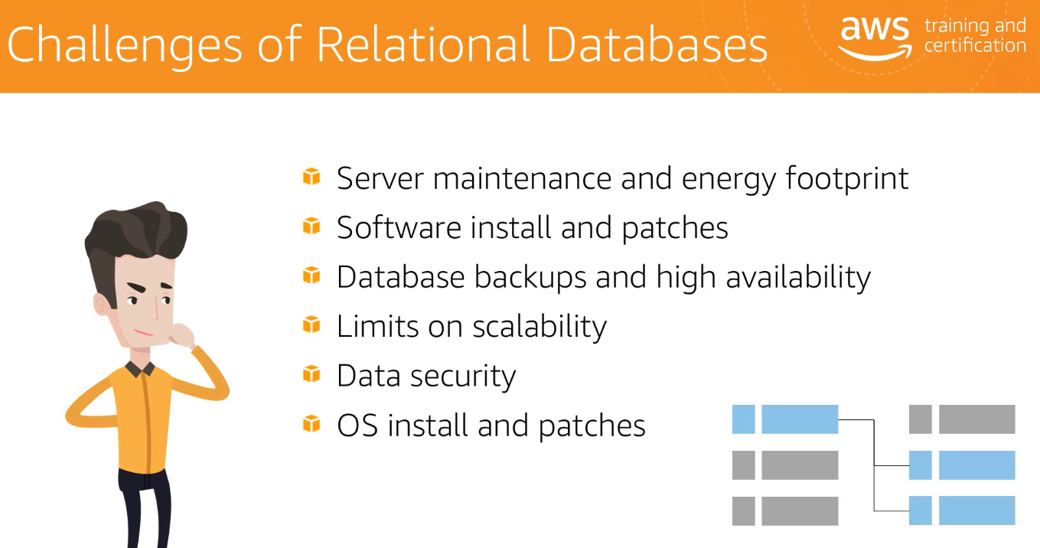

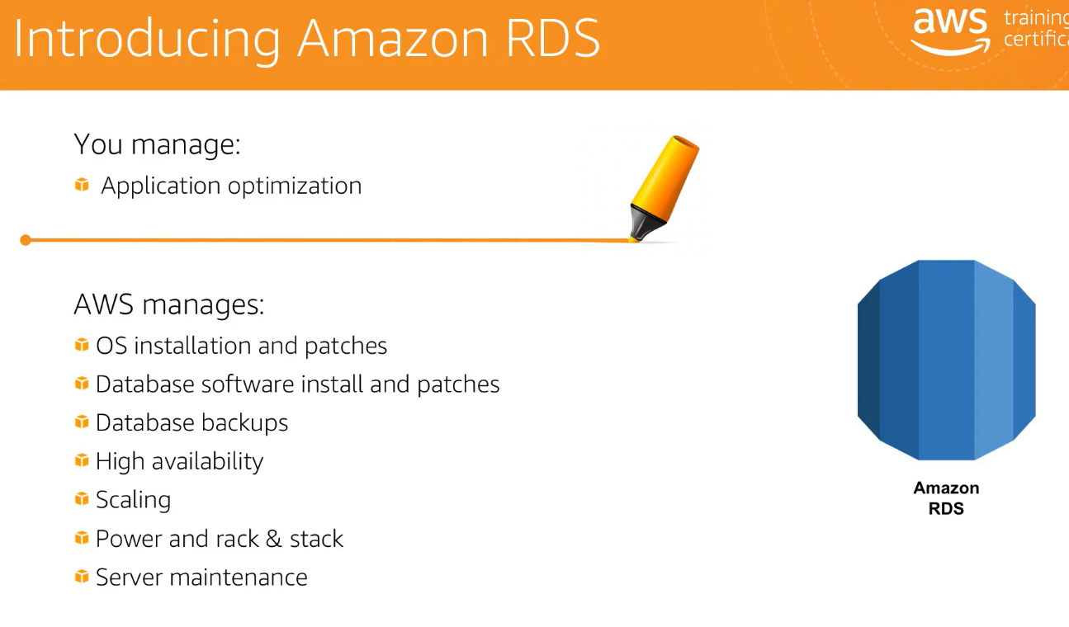

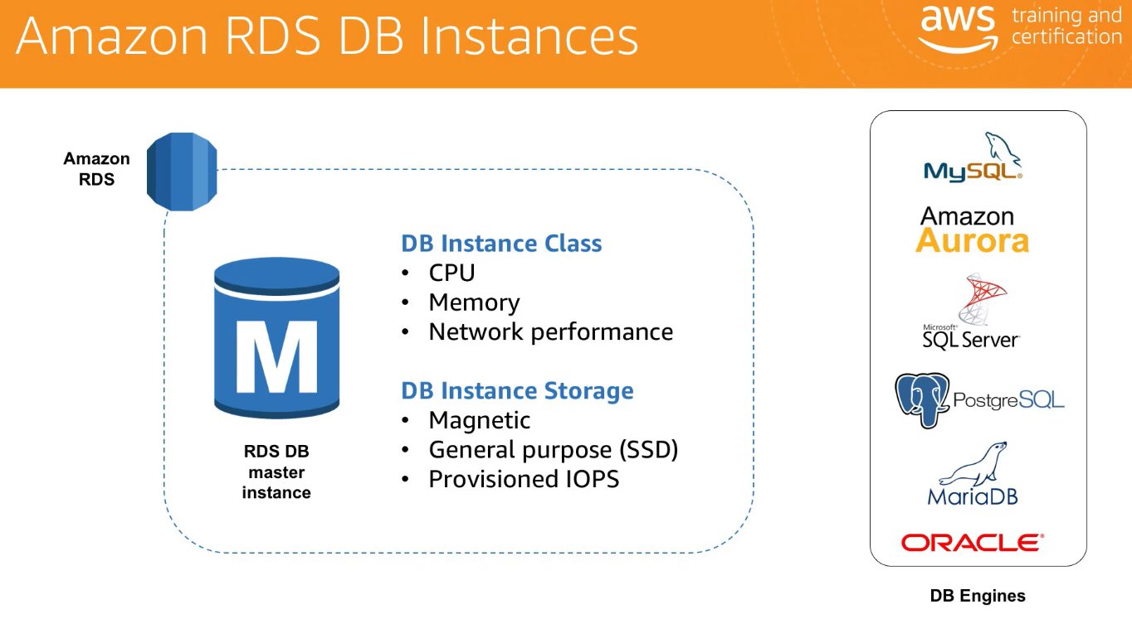

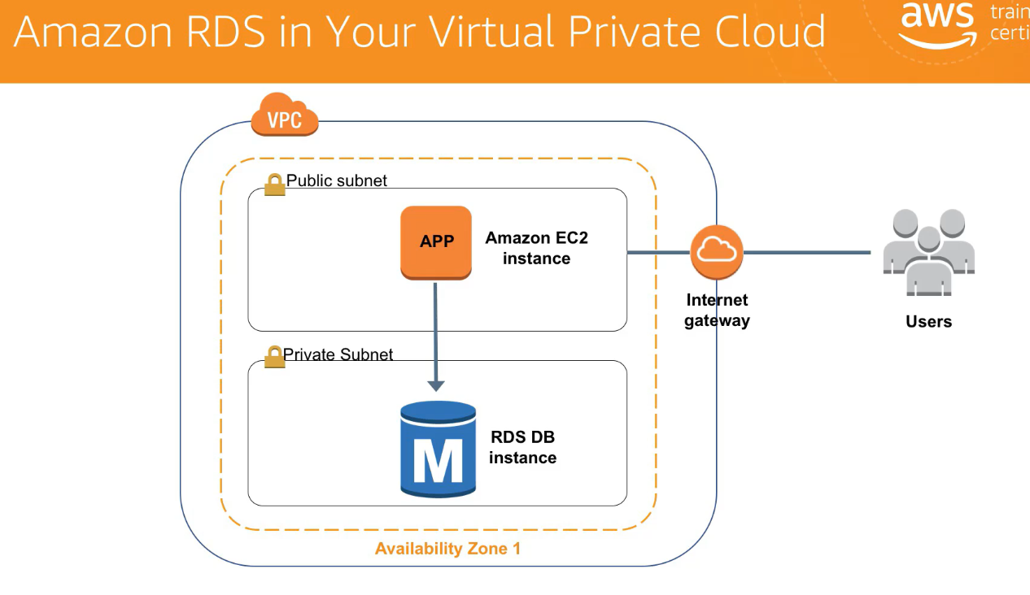

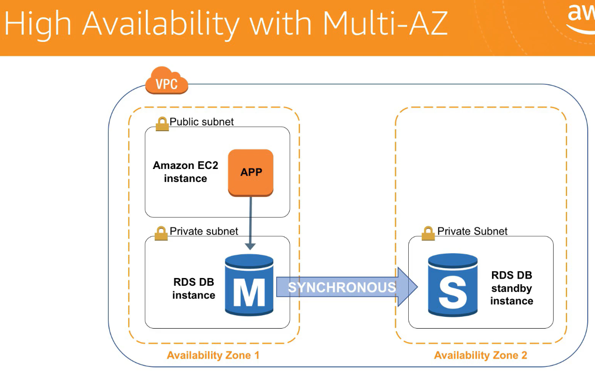

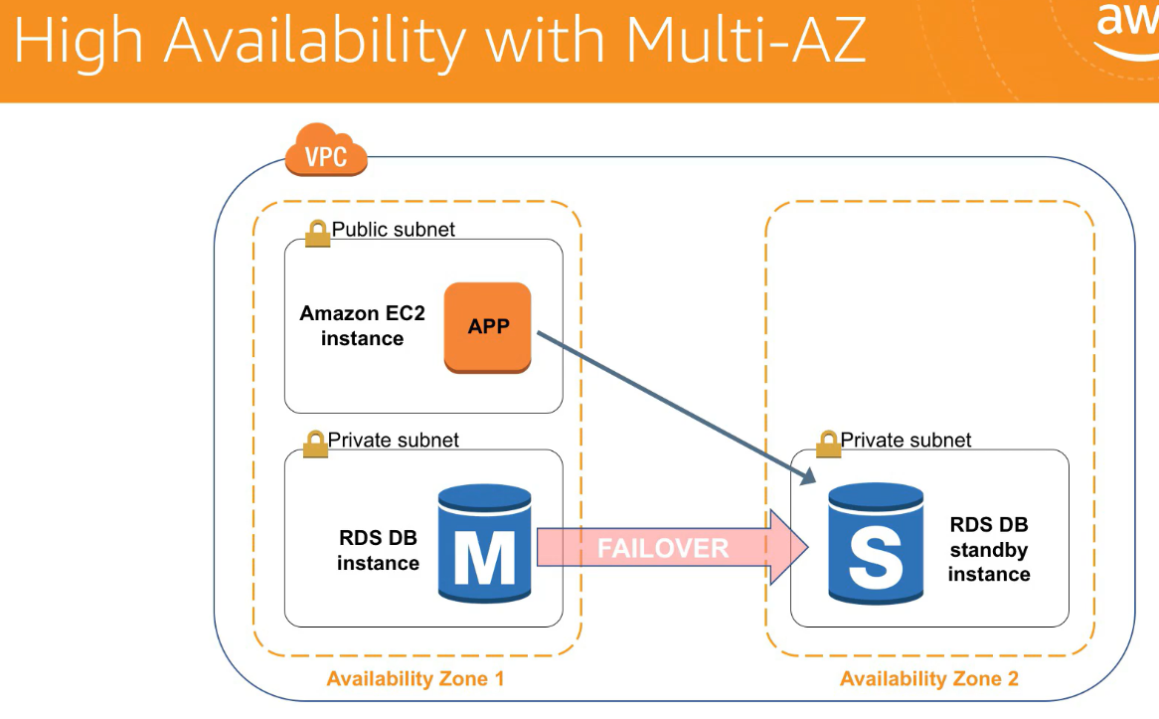

What is AWS Lambda used for?

**AWS Lambda** is a serverless compute service that runs your code in response to events and automatically manages the underlying compute resources for you. You can use **AWS Lambda** to extend other **AWS** services with custom logic, or create your own back-end services that operate at **AWS** scale, performance, and security.

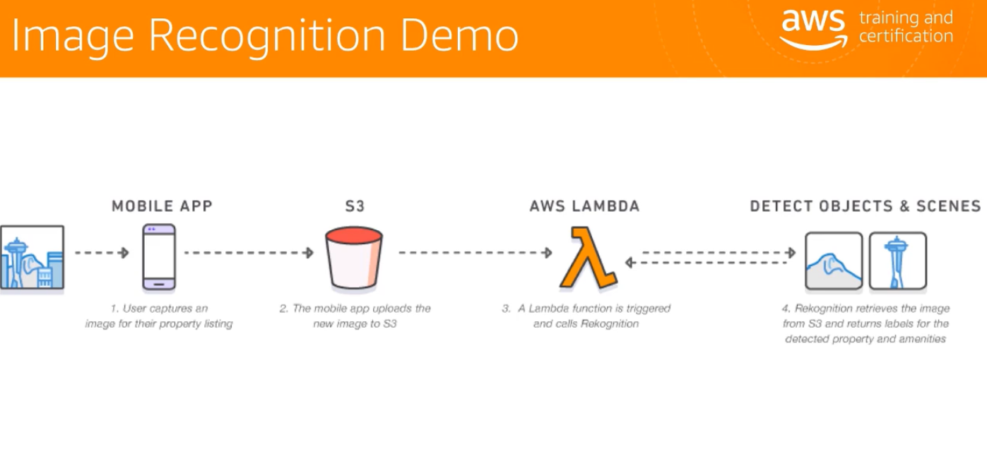

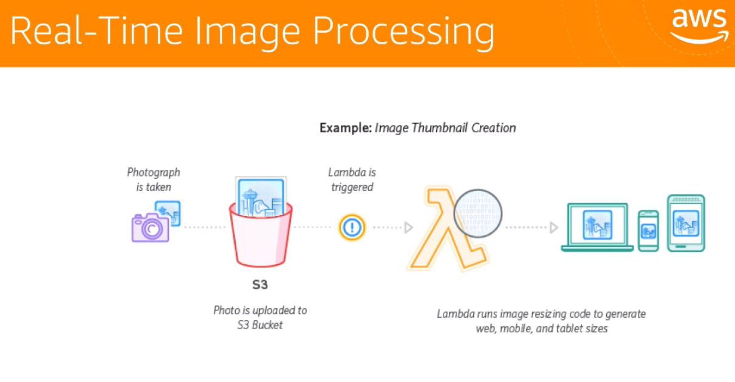

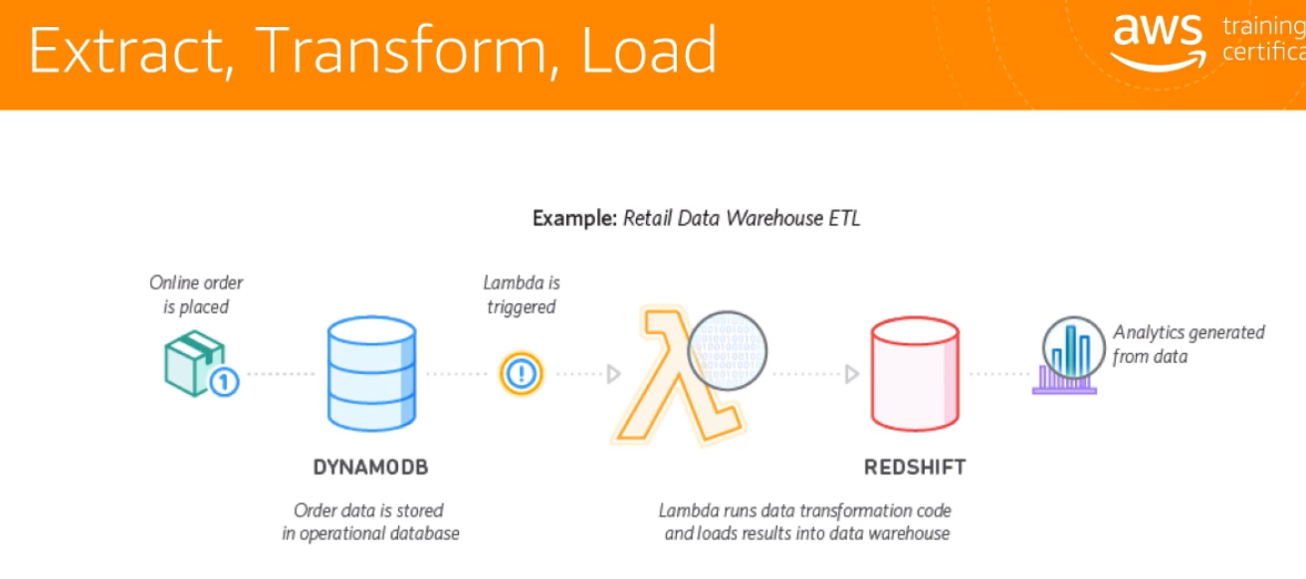

**Difference between Elastic Beanstalk** and **EC2**

**EC2** is the **Amazon** service that lets you create and launch servers **in the AWS** cloud. ... In other words, **Elastic Beanstalk** brings together **AWS** services like **EC2**, Auto Scaling, and S3 for the purpose of deploying **elastic** cloud applications.

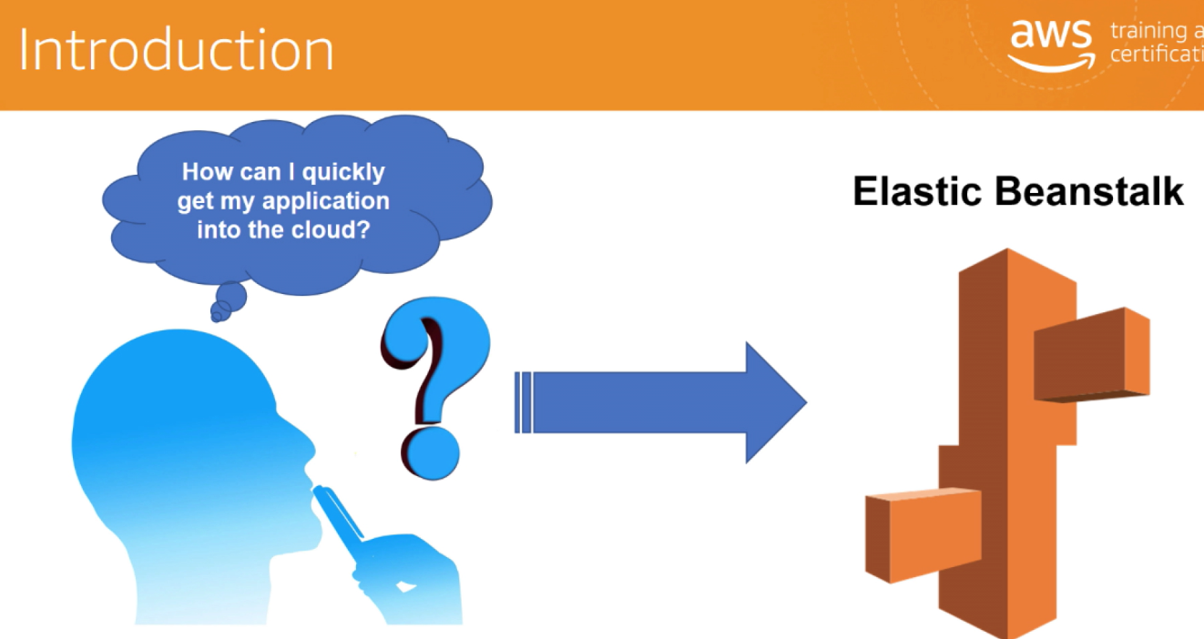

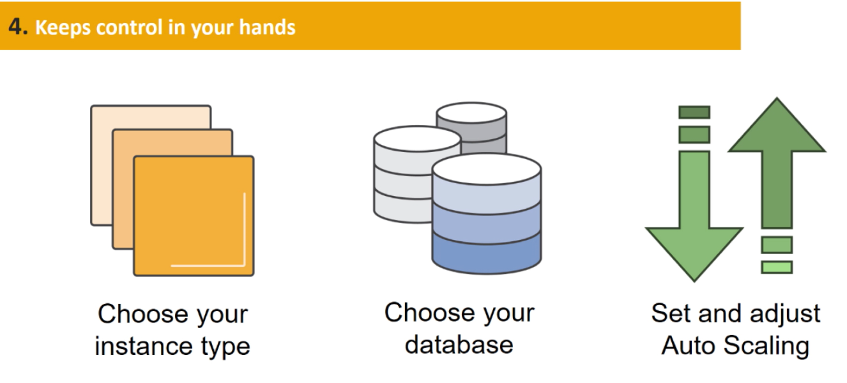

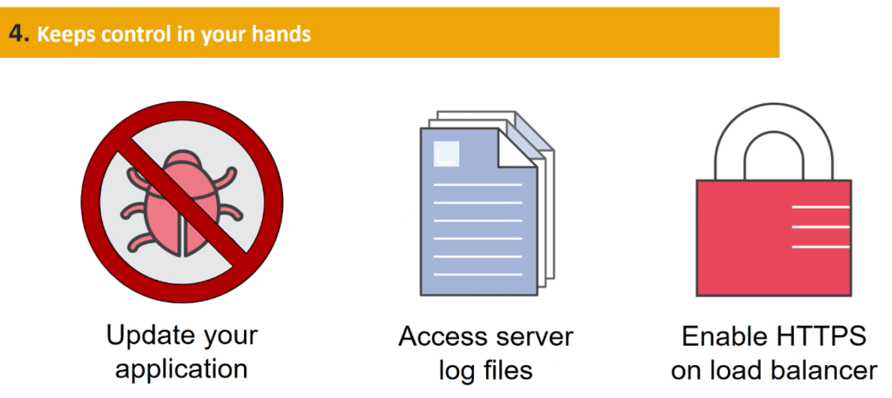

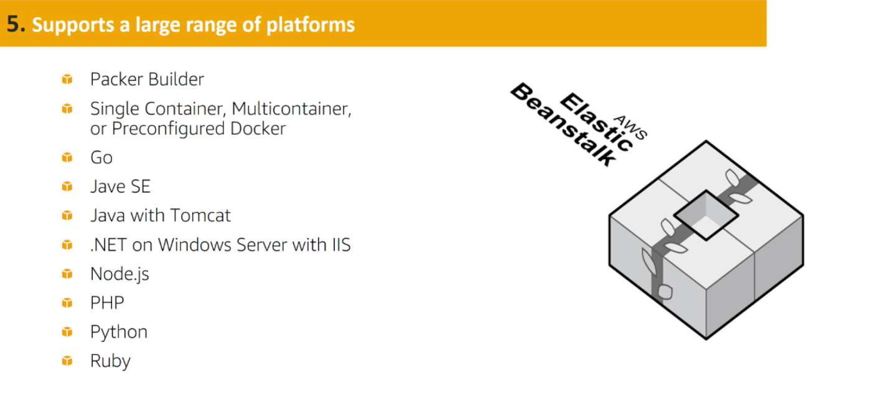

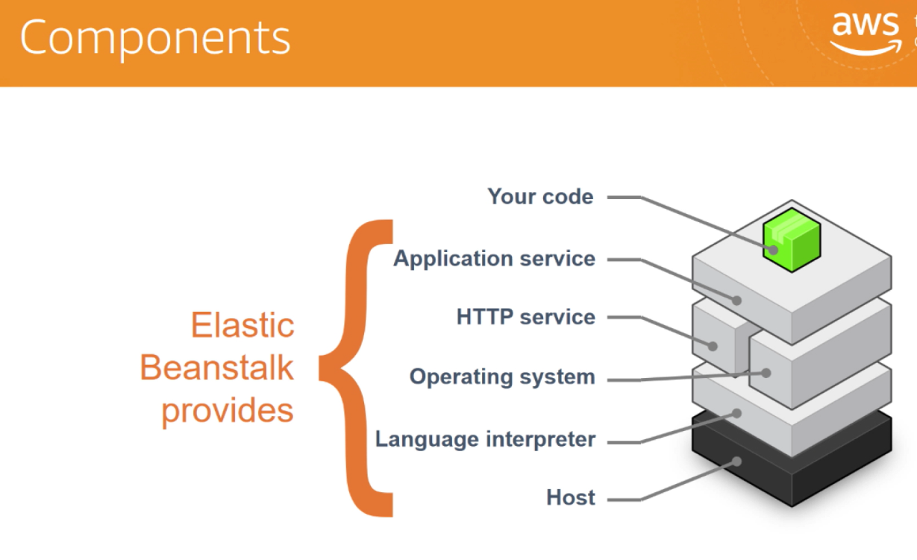

What is AWS Simple Notification Service?

Amazon **Simple Notification Service** (SNS) is a highly available, durable, secure, fully managed pub/sub messaging **service** that enables you to decouple microservices, distributed systems, and serverless applications. ... Additionally, SNS can be used to fan out **notifications** to end users using mobile push, SMS, and email.

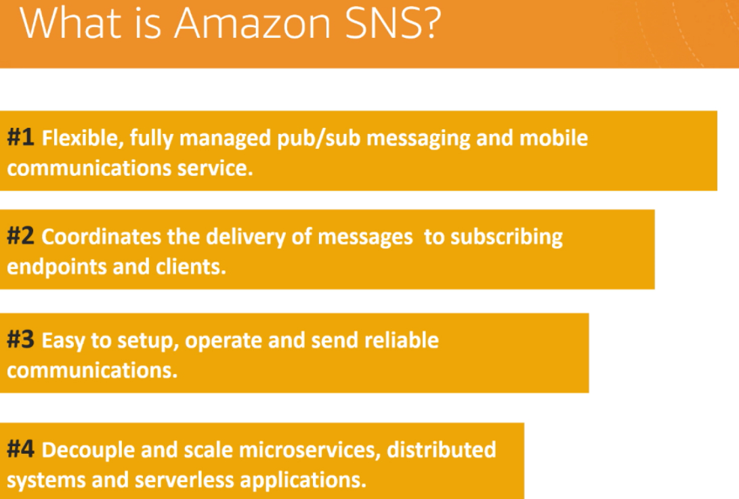

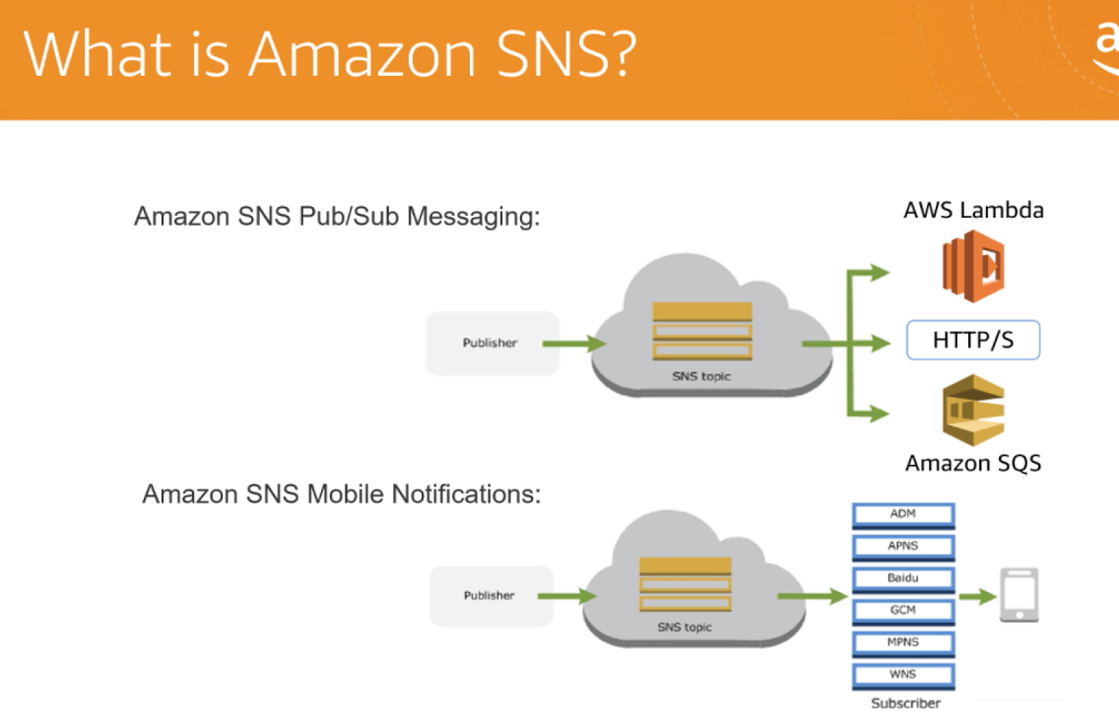

Using s3 we can configure sns.

First create sns then configure using s3

**Amazon CloudWatch** is a monitoring service for **AWS** cloud resources and the applications you run on **AWS**. You can use **Amazon CloudWatch** to collect and track metrics, collect and monitor log files, set alarms, and automatically react to changes in your **AWS** resources.

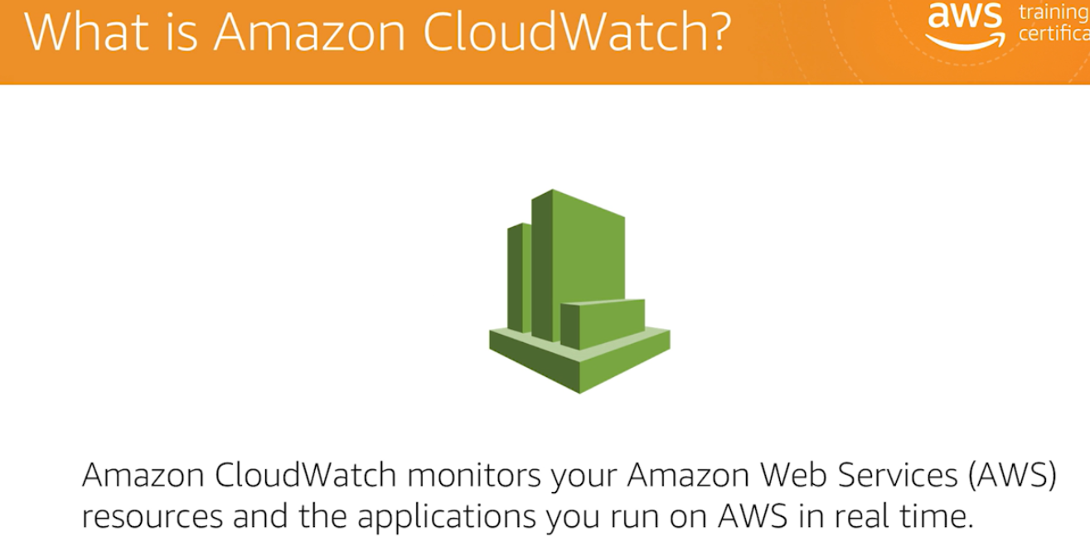

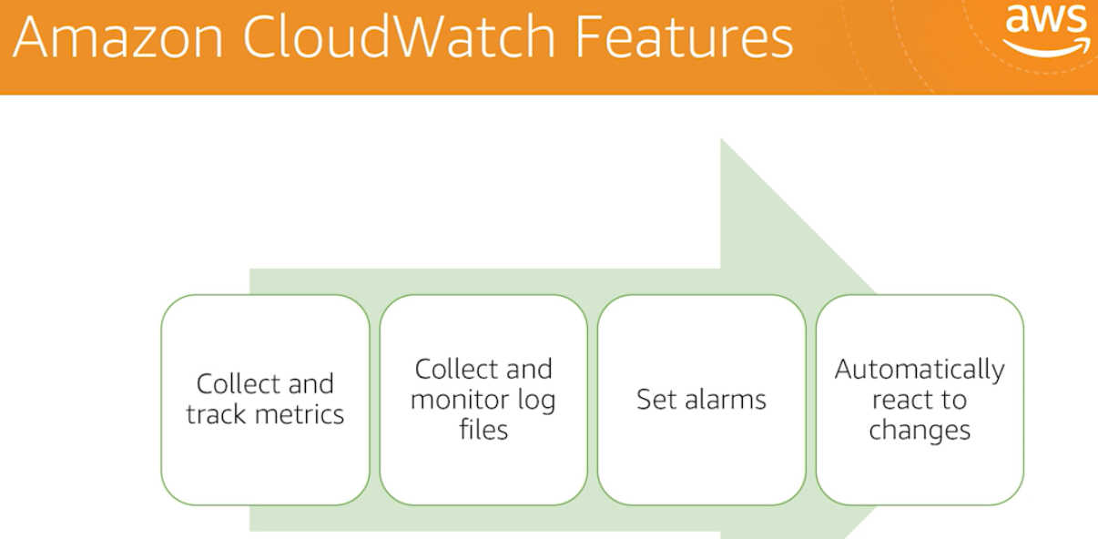

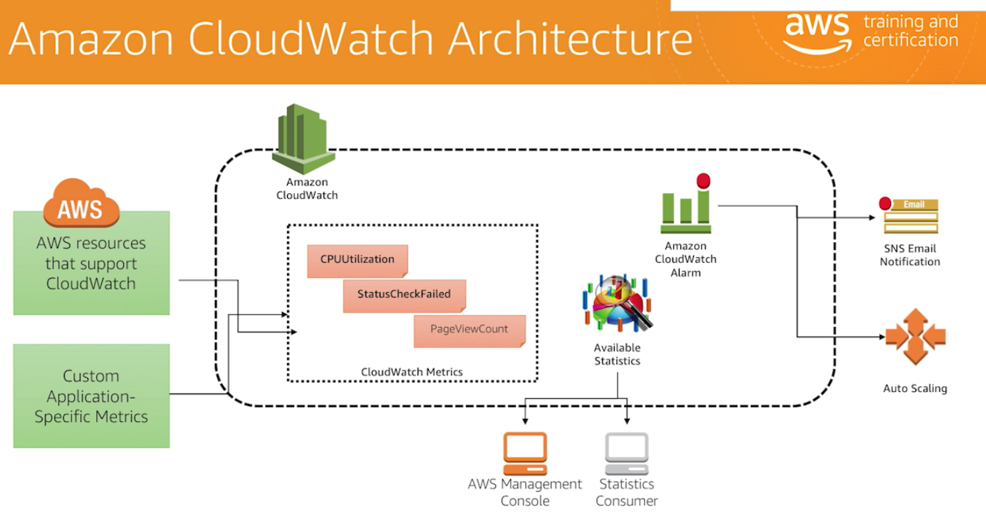

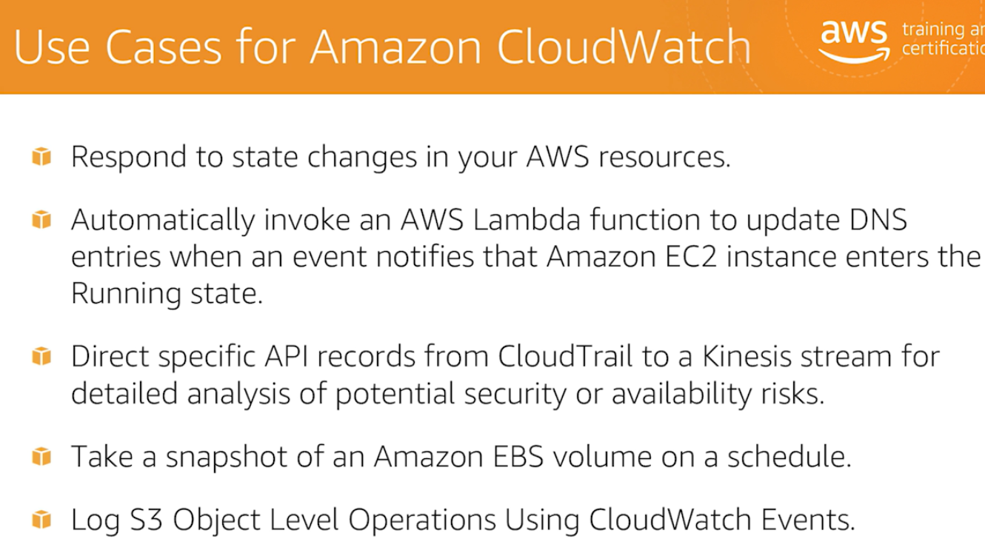

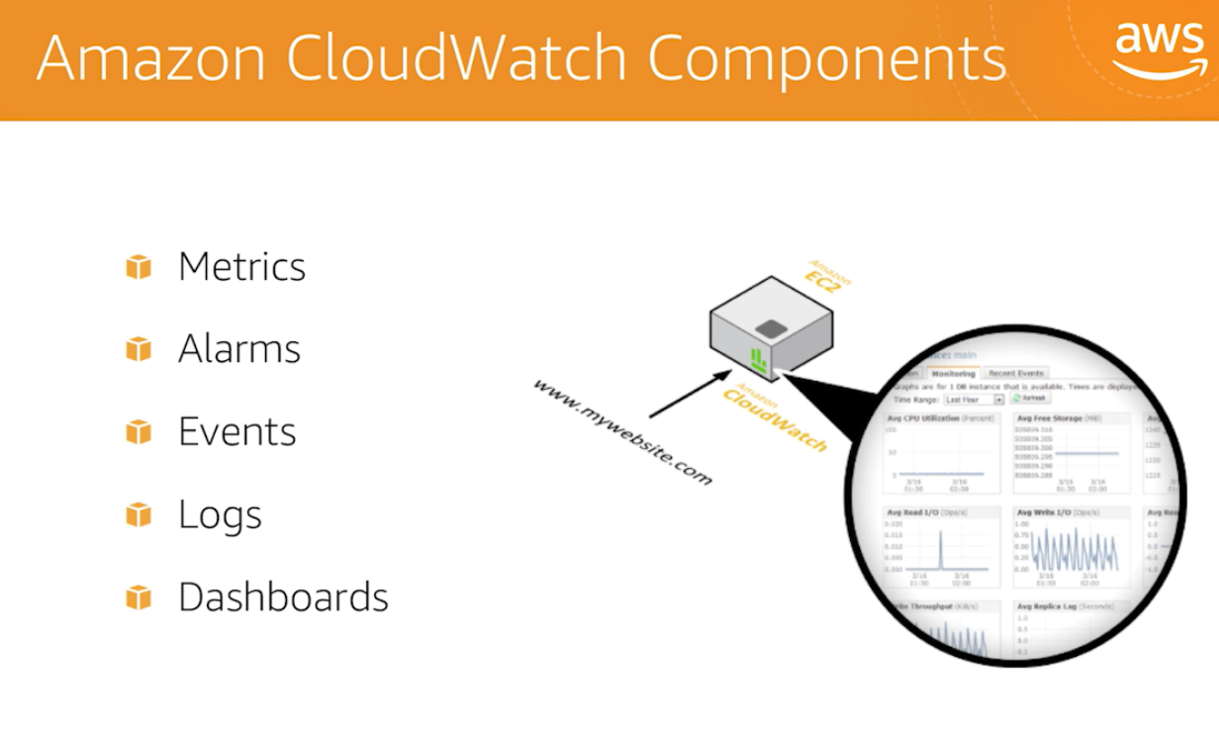

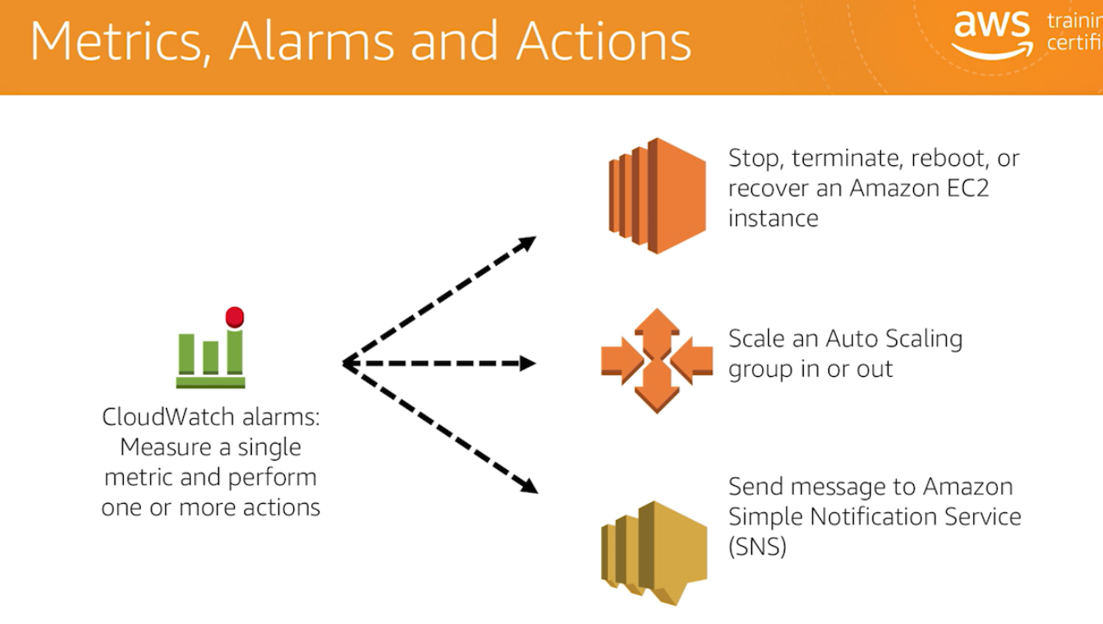

**AWS** Identity and Access Management (**IAM**) enables you to manage access to **AWS** services and resources securely. Using **IAM**, you can create and manage **AWS** users and groups, and use permissions to allow and deny their access to **AWS** resources. **IAM** is a feature of your **AWS** account offered at no additional charge.

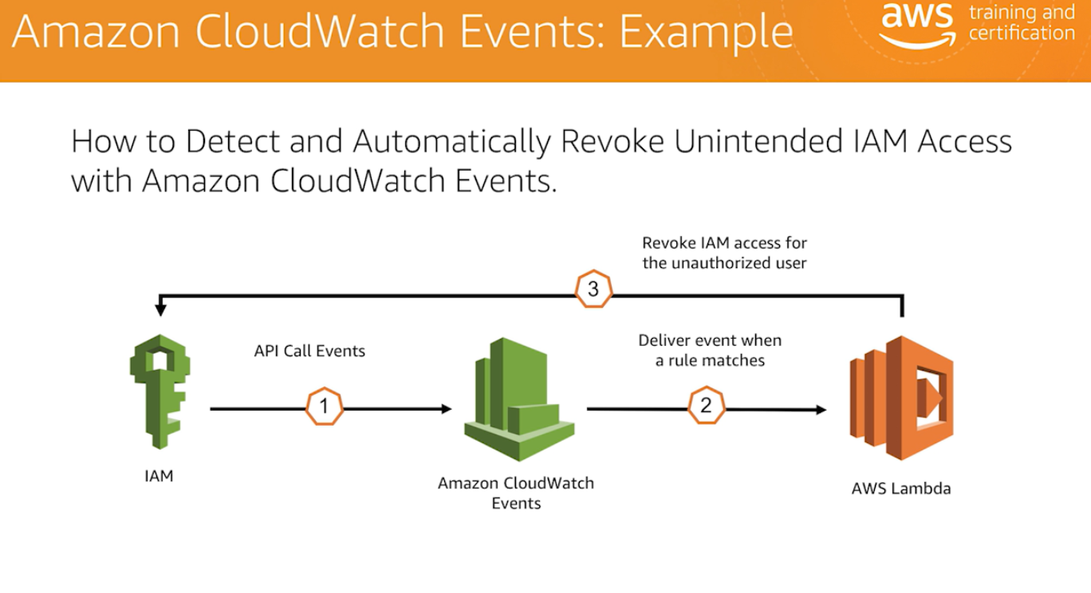

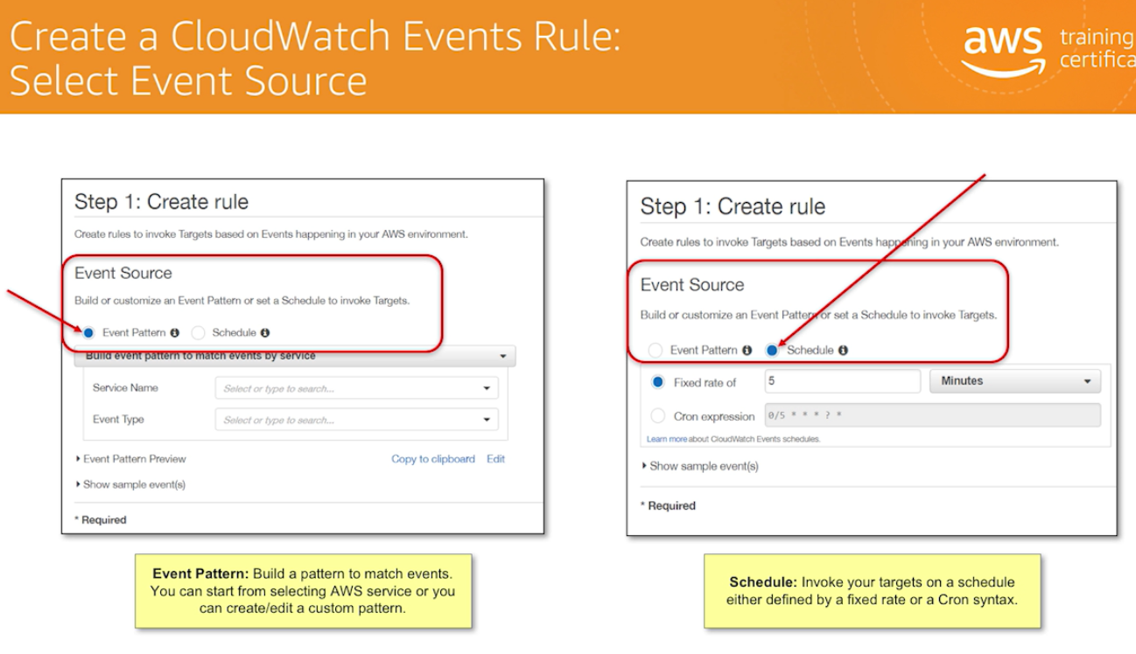

**Amazon CloudFront** is a fast content delivery network (**CDN**) service that securely delivers data, videos, applications, and APIs to customers globally with low latency, high transfer speeds, all within a developer-friendly environment.

What is AWS CloudFormation used for?

**AWS CloudFormation** is a service that helps you model and set up your **Amazon** Web Services resources so that you can spend less time managing those resources and more time focusing on your applications that run in **AWS**.

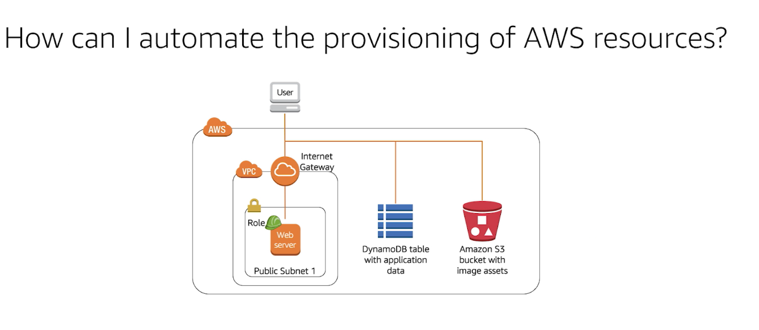

What is AWS CloudFormation stack?

A **stack** is a collection of **AWS** resources that you can manage as a single unit. In other words, you can create, update, or delete a collection of resources by creating, updating, or deleting **stacks**. All the resources in a **stack** are defined by the **stack's AWS CloudFormation** template.

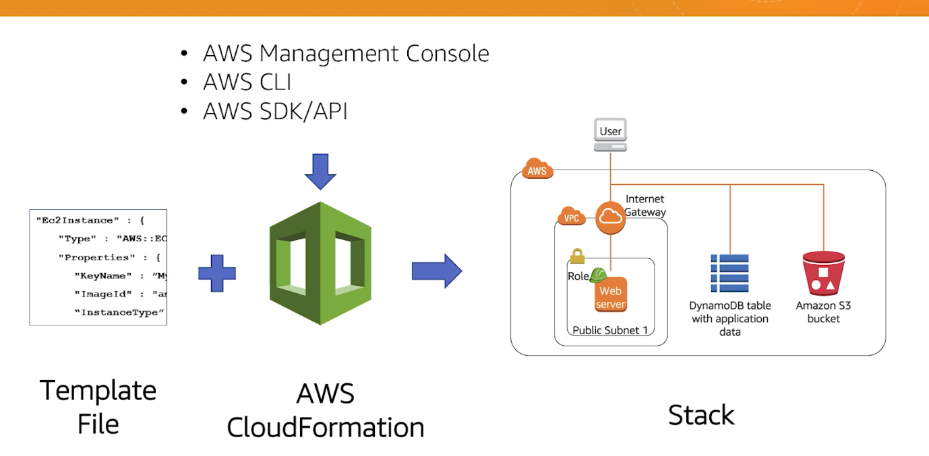

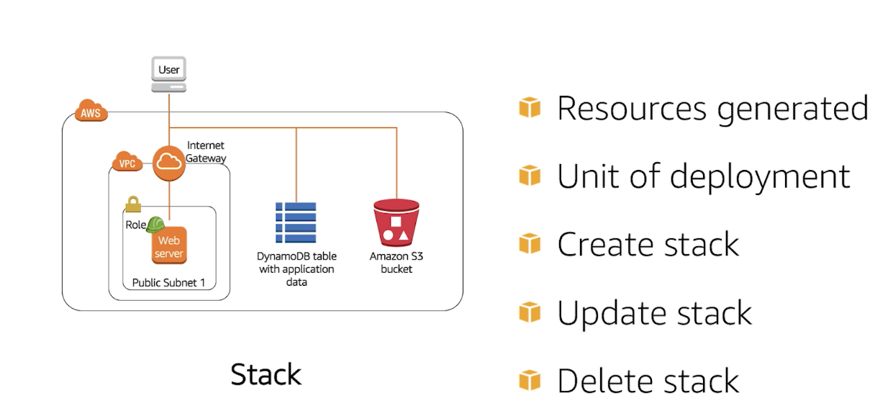

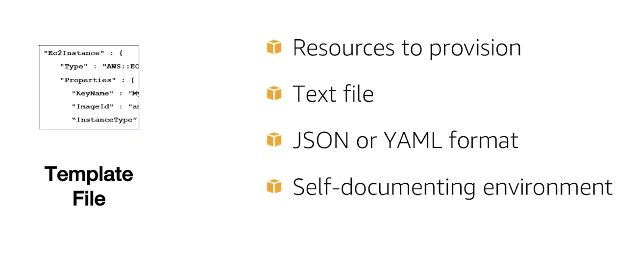

Note: we can use same template for different environment

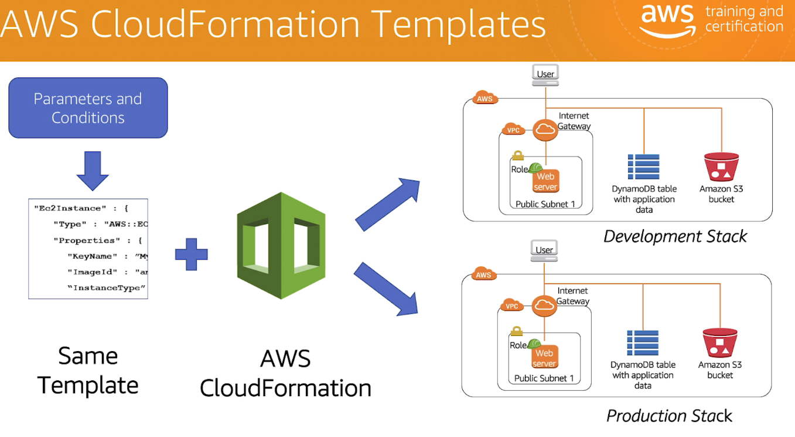

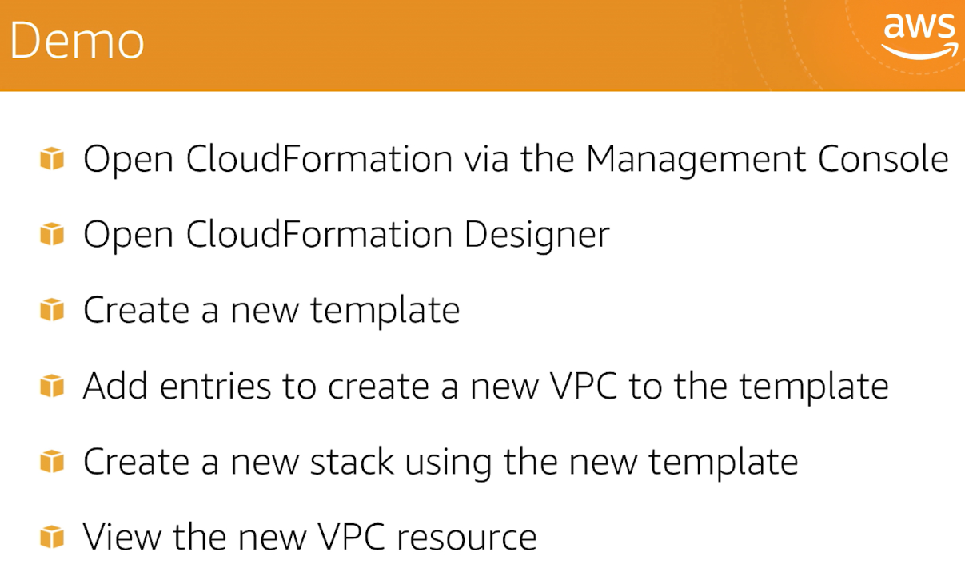

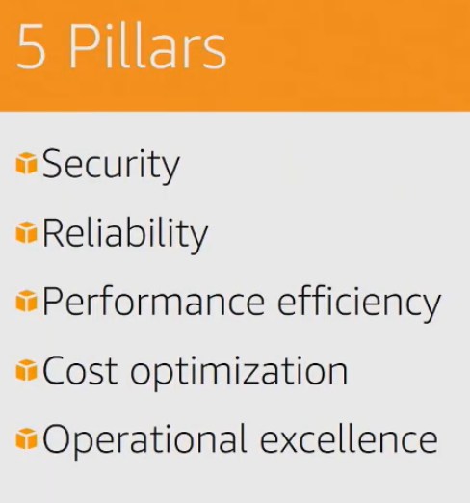

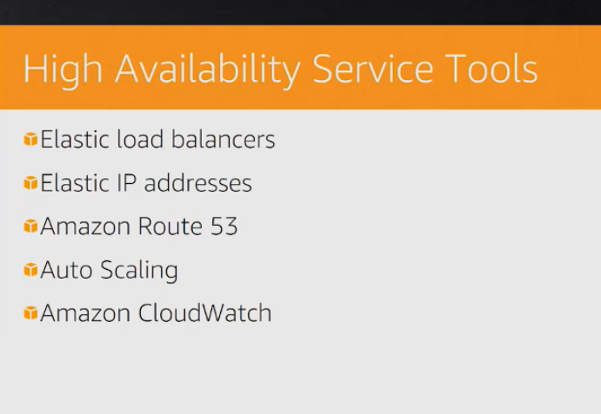

VPCs and Subnets

A virtual private cloud (**VPC**) is a virtual network dedicated to your **AWS** account. It is logically isolated from other virtual networks in the **AWS** Cloud. You can launch your **AWS** resources, such as Amazon EC2 instances, into your **VPC**.

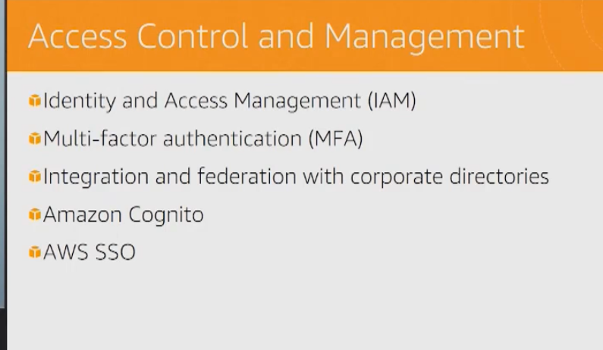

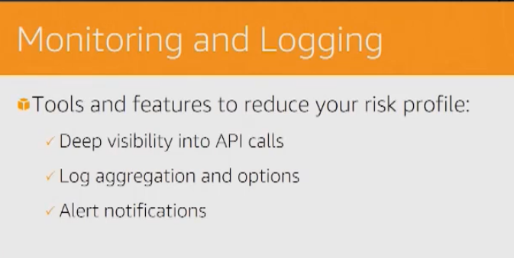

What is hypervisor in cloud computing?

**Hypervisors** are virtual machine monitor(VMM) that enables numerous virtual operating systems to simultaneously run on a computer system. These virtual machines are also referred as guest machines and they all share the hardware of the physical machine like memory, processor, storage and other related resources.

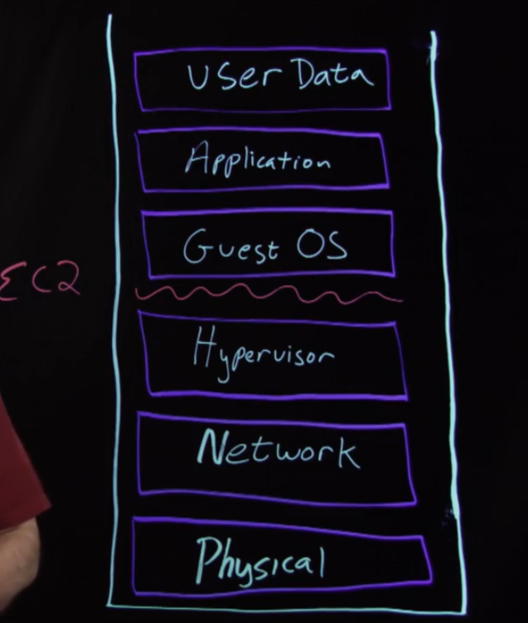

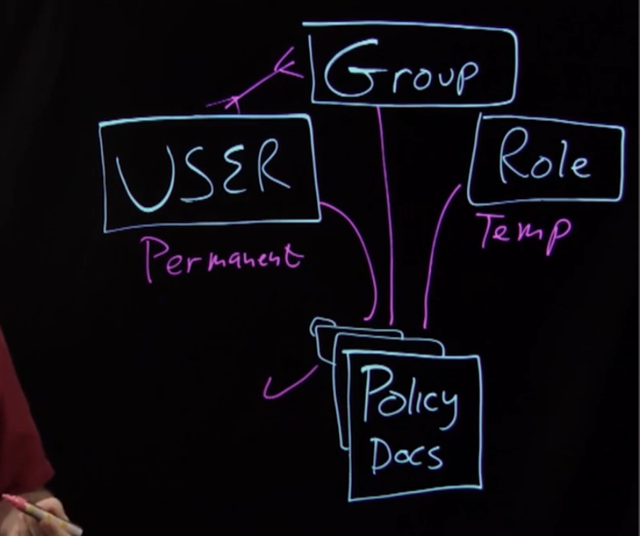

**Amazon Inspector** is an automated security assessment service that helps improve the security and compliance of applications deployed on **AWS**.

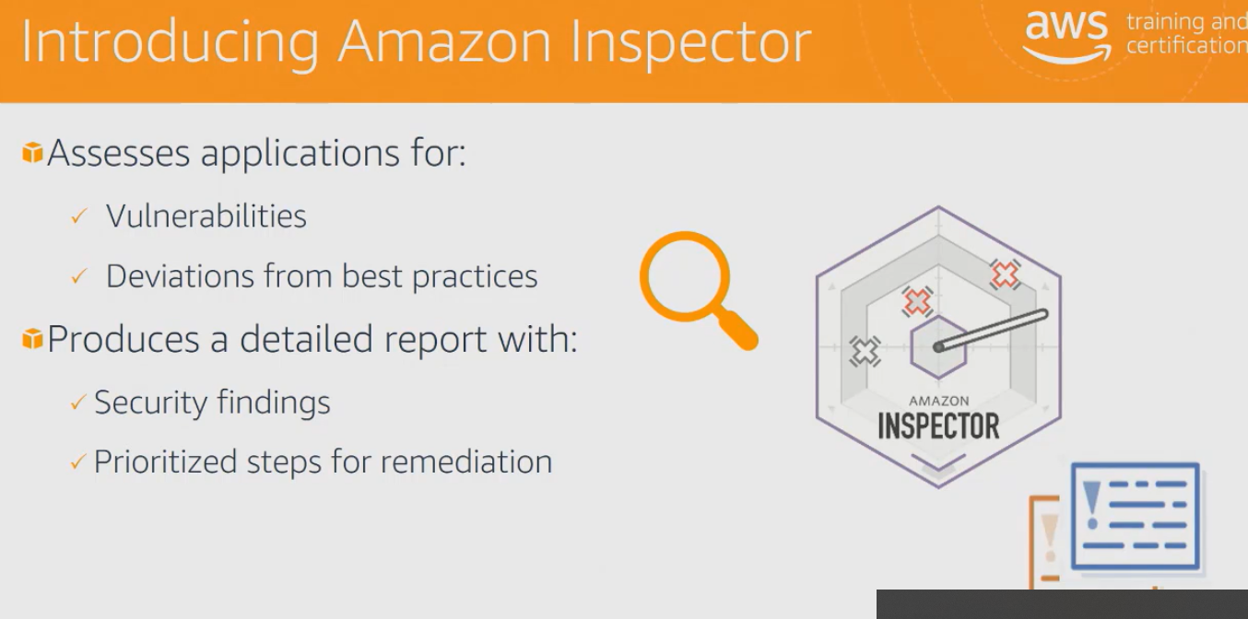

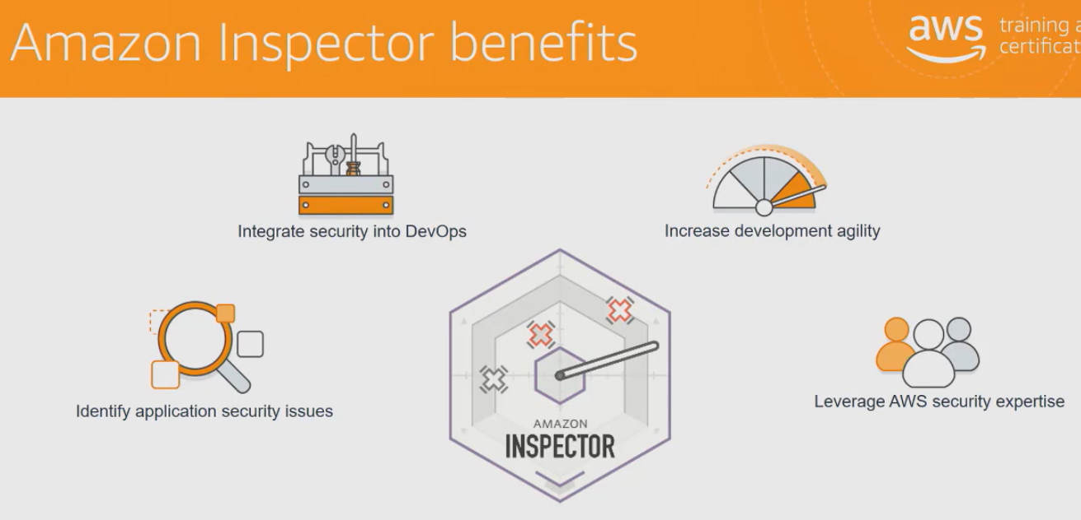

**AWS Shield** is a managed Distributed Denial of Service (DDoS) protection service that safeguards applications running on **AWS**. ... **AWS Shield** Standard defends against most common, frequently occurring network and transport layer DDoS attacks that target your web site or applications.

What is a distributed denial of service system?

A **distributed denial**-of-**service** (**DDoS**) attack is an attack in which multiple compromised computer **systems** attack a target, such as a server, website or other network resource, and cause a **denial** of **service** for users of the targeted resource.

